

**PES UNIVERSITY**

**(Established under Karnataka Act No. 16 of 2013)**

**100-ft Ring Road, Bengaluru – 560 085, Karnataka, India**

***Report on***

**INTENSITY CONTROL OF HOME APPLIANCES**

**USING MQTT PROTOCOL**

**Jan - May 2021**

**Jun – Sept 2021**

**Department of ECE**

**PES University**

**Bengaluru -560085**



**PES UNIVERSITY**

**(Established under Karnataka Act No. 16 of 2013)**

**100-ft Ring Road, Bengaluru – 560 085, Karnataka, India**

***Report on***

**‘Intensity Control of Home Appliances**

**Using MQTT Protocol’**

***Submitted by***

**ROHAN N KALPAVRUKSHA PES1201802830**

**AKHIL V NAYANEGALI PES1201801945**

**ROSHAN N KALPAVRUKSHA PES1201802834**

**MRIDHULA SRIHARSHA PES1201801122**

**Jan – May – 2021**

**Jun - Dec - 2021**

**under the guidance of**

**Dr. ANURADHA M**

**Professor and Chairperson**

**Department of ECE**

**PES University**

**Bengaluru -560085**

**FACULTY OF ENGINEERING**

**DEPARTMENT OF ELECTRONICS AND COMMUNICATION ENGG**

**PROGRAM B. TECH**



**CERTIFICATE**

*This is to certify that the Report entitled*

**‘Intensity Control of Home Appliances using MQTT Protocol’**

*is a bona fide work carried out by*

**ROHAN N KALPAVRUKSHA (PES1201802830)**

**ROSHAN N KALPAVRUKSHA (PES1201802834)**

**AKHIL V NAYANEGALI (PES1201801945)**

**MRIDHULA SRIHARSHA (PES1201801122)**

In partial fulfillment for the completion of course work in the Program of Study B. Tech in Electronics and Communication Engineering, under rules and regulations of PES University, Bengaluru during the period Jan - Sep 2021. It is certified that all corrections/suggestions indicated for internal assessment have been incorporated in the report. The report has been approved as it satisfies the academic requirements in respect of Capstone project work.

*Signature with date & Seal Signature with date & Seal*

*Dr. Anuradha M Dr. Anuradha M*  *Internal Guide Chairperson*

*Signature with date & Seal*

*Dr. B. K. Keshavan*

*Dean - Faculty of Engg. &Technology*

Name and signature of the examiners:

1.

2.

**DECLARATION**

We, *Rohan N Kalpavruksha, Roshan N Kalpavruksha,* *Akhil V Nayanegali**and**Mridhula Sriharsha***,** hereby declare that the report entitled, *‘****Intensity Control of Home Appliances using MQTT Protocol’,*** is an original work done by us under the guidance of **Dr. *Anuradha M***, Chairperson, ECE Department and is being submitted in partial fulfillment of the requirements for completion of course work in the Program of Study, B. Tech in Electronics and Communication Engineering.

**PLACE:** Bangalore

**DATE:** 07-09-2021

**NAME AND SIGNATURE OF THE CANDIDATES**

1. **ROHAN N KALPAVRUKSHA**

2. **ROSHAN N KALPAVRUKSHA**

3. **AKHIL V NAYANEGALI**

4. **MRIDHULA SRIHARSHA**

**ABSTRACT**

To maintain a comfortable living conditions at home, home automation and monitoring can be made use of by making use of the Internet of Things. This IoT project focuses on controlling the intensity of bulb and fan at different levels by making use of IoT devices through various input methods such as voice using google assistant, slide bar using ubidots server and based on our gesture with the help of an accelerometer which in turn helps avoid unnecessary wastage of power. It helps the user to control the electronic devices using his/her smartphone for voice and slide bar technique. This project also includes a smart band which helps in controlling the intensities of devices taking hand gestures as input.

**ACKNOWLEDGEMENTS**

We extend our deep sense of gratitude to our Chairman PES University, **Dr. M.R.Doreswamy**, our Chancellor, **Prof. Jawahar Doreswamy**, our Pro- Chancellor, **Dr. Suryaprasad J**, our Dean, Faculty of Engineering and Technology **Dr.B.K.Keshavan** and our Registrar **Dr.K.S.Shridar** for giving us a platform to work on this project.

We would like to extend our warm gratitude to PES University Electronics and Communication Dept. for allowing us to work with them on “Intensity Control of Home Appliances using MQTT Protocol”.

Our special heartfelt thanks to our respected guide **Dr. Anuradha M** for her kind co-operation, encouragement, supervision and also for providing all the necessary information with respect to the project which helped all of us in completing the same smoothly.

Also, we are thankful to our panelist members who helped us enrich our knowledge about the topic by sharing her valuable understandings and enlightening us with their skills.

**TABLE OF CONTENT**

|  |  |  |
| --- | --- | --- |
| **Sl no.** | **Topic** | **Page no.** |
| 1 | List of Tables and Figures | 8 |
| 2 | Introduction | 10 |
| 3 | Literature Review | 11 |
| 4 | Methodology | 40 |
| 5 | Results | 72 |
| 6 | Conclusion | 16 |
| 7 | References | 17 |

1. **LIST OF TABLES AND FIGURES**

Figures

Fig 3.2.1 Structure of MQTT Protocol

Fig 4.1.1 Ubidots Website (Dashboard)

Fig 4.1.2 Ubidots Devices

Fig 4.1.3 Adding a new device (1)

Fig 4.1.4 Adding a new device (2)

Fig 4.1.5 Selection of new device from the device list

Fig 4.1.6 Adding a new variable

Fig 4.1.7 Selection of variables

Fig 4.1.8 Adding widgets to the Dashboard

Fig 4.1.9 Setup of Ubidots Dashboard for MQTT broker

Fig 4.1.10 Block Diagram of the proposed model

Fig 4.2.1 AC Input with 50Hz frequency

Fig 4.2.2 Output of the bridge rectifier

Fig 4.2.3 Output of Zero Crossing detection Circuit

Fig 4.2.4 Output of the AC wave with Triac control

Fig 4.2.5 Comparison of AC wave with the output of leading phase edge dimming

Fig 4.2.6 Schematic of the Subscriber Circuit

Fig 4.2.7 Setup to demonstrate the working

Fig 4.2.8 The Subscriber Circuit

Fig 4.2.9 The side view of the Subscriber Circuit

Fig 4.3.1 Connections between NodeMCU and MPU6050

Fig 4.3.2 The design of the wristband (1)

Fig 4.3.3 The design of the wristband (2)

Fig 4.4.1 Block diagram of voice control

Fig 4.4.2 IFTTT home screen

Fig 4.4.3 Creating new applet

Fig 4.4.4 Selecting trigger device

Fig 4.4.5 Selecting trigger options

Fig 4.4.6 Filling the fields of the trigger device

Fig 4.4.7 selection of the action service

Fig 4.4.8 selection of the action service (1)

Fig 4.4.9 selection of the action service (2)

Fig 4.4.10 Voice Commands in Google Assistant

Fig 4.5.1 Output of the subscriber circuit

Fig 4.5.2 Output of the Publisher circuit on serial monitor (1)

Fig 4.5.2 Output of the Publisher circuit on serial monitor (2)

Fig 5.1 Slide bar control of the appliance

Fig 5.2 Voice control of the appliance

Fig 5.3 Gesture control of the appliance

Table

Table 3.2.1 Comparision of MQTT Protocol with other IoT Protocol

1. **INTRODUCTION**

We live in an exciting time where everyday things are becoming smart. As automation technology advances, life is getting simpler and better in all aspects. Internet of Things gives the accesses to control some parameters of devices at home remotely through the Internet. Hence IoT can be defined as a network of embedded objects that helps connect and exchange data with other devices via internet.

Day by day the number of internet users are rapidly increasing over the past decade has made it a part of life. This project aims to developing a system which can control the intensity of light and speed of the fan by various input methods such as voice, slide bar and gesture that is relatively affordable and users friendly. We aim to create a wrist band for specially challenged people which can help them control light/fan at various levels.

This IoT project focuses on controlling the intensity of bulb and fan at different levels by making use of IoT devices through various input methods such as voice using google assistant, slide bar using ubidots server and based on our gesture with the help of an accelerometer which in turn helps avoid unnecessary wastage of power. This project also includes a smart band which helps in controlling the intensities of devices taking hand gestures as input.

We have made use of MQTT protocol for transferring data from user to devices via Wi-Fi. Message Queuing Telemetry Transport is abbreviated as MQTT which is simple, light weight messaging protocol. The specifications of MQTT such as MQTT being built on top of TCP and lets TCP do a lot of hard work and no payload definitions was specified has made us take up this protocol to solve the problem stated. It provides many advantages such as efficient distribution of information, increased scalability, maximizes available bandwidth, reduces update rate to seconds.

1. **LITERATURE REVIEW**

**3.1 “A study of Conventional Protocols applicable to the emerging IoT Systems and Devices”**

The study analyses and contrasts three important parameters: operational frequency, trans-reception bandwidth, and downlink rate. In addition, the research presents an overall view of selecting the best procedure for each application. It is possible to shape and use a very light-weight model of conventional data transfer protocols since a new set of communication rules for IoT equipment and devices is being developed and researched. As a result, innovation has the opportunity to provide a real-time, effective, dependable, robust, and expandable framework that can be beneficial in processing and managing large quantities of information that will be exchanged in an IoT-governed environment.

Bluetooth is one of the most frequently used short-range data transfer techniques and has been applied in numerous electronic goods and in-house "Products." Wearable items such as smart bracelets, smart rings, and so on can be connected to smartphones via Bluetooth for the transfer of sensor information. 2.4GHz (ISM) frequency, 50m-150m working range, and relaying rates of up to 1Mbps make it suitable for "Things" located at a lesser distance.

Like Bluetooth, ZigBee is a flexible wireless technology. The existence of a higher-order access point in ZigBee makes it more suitable for commercial applications. Because it makes use of the IEEE 802.15.4 protocol and several different features including RF4CE (ZigBee Remote Control) and ZigBee PRO, it's a dependable wireless network solution for industrial applications.

Communication technologies with short range, such as NFC and SIGFOX are two possibilities for interconnecting linked IoT devices. NFC provides bidirectional connectivity and data transmission at a comparable lower speed of 100-420Kbps at a 13.56MHz operational frequency. Because of its efficient transmission, this technology offers a greater level of security and may thus be utilized in situations where sensors are located extremely close to an IoT device's decision-making circuitry.

Z-Wave is a low-power RF network technology that may be utilised for the low-power connectivity of "Things" or devices such as home appliances centered on IoT. IoT-based home appliances, such as smart thermostats, can be connected to the platform in a matter of seconds. NEUL can also work at lower frequencies, maybe up to 1GHz. It intelligently employs a little part of the television transmission's White Space Spectrum. IP-based technology is used. NEUL is an IP-based technology that is primarily based on IPv6 and is known as IPv6 Low-Power Wireless Personal Area Network (6LowPAN).

“Message Queue Telemetry Transport” (MQTT) is a flexible and open-source protocol created for monitoring of IoT devices from a distance. Its major role is to collect information from different indeterminate or routinely placed systems and to deliver it to unified infrastructure and "middleware" via a "hub-and-spoke" topology. The protocol's functioning is channelized from the data generator (Publisher) to the end consumers via auxiliary circuitry (Broker) that monitors, regulates, and verifies the data's authenticity.

The protocols SIGFOX and NEUL can be used to handle Internet of Things devices that are randomly deployed in a remote region, however, their data transfer speeds of 1kbps for SIGFOX and 100kbps for NEUL restrict their use. Bluetooth systems may have a fast data transfer rate, but their range is just 100-150 meters (Smart Bluetooth).

**3.2 “A Comparative analysis of MQTT and IoT**

**application protocols.”**

With this research, we contribute to the existing research and case study of Internet-of-things (IoT) protocols by examining one of the most important IoT protocols: the MQTT protocol. The protocol's interoperability may be compared to that of other "application-layer protocols." Additional related work has finalized the communication method and assessment procedures This relative study aims to uncover the drawbacks and unsolved issues of this in contrast to numerous software protocols.In order to build the groundwork for future MQTT research, this study's goal is to establish a foundation. The protocol will be refined and assessed based on the findings. Unresolved issues that come about as a result of the investigation.

As the Internet of Things (IoT) has grown, it has become more important to select the right protocol for each application or object. The researchers conducted a thorough analysis of IoT network protocols, comparing them from multiple perspectives. The authors divided the protocol into the following categories based on its architecture: The protocols required for high computational power in the cloud services layer, like AMQP, include COAP and MQTT, which are for confined applications and Internet of things devices with limited functionality.

When it comes to information transfer, COAP uses the UDP protocol as a request/response paradigm while MQTT is a publish/subscribe paradigm that utilises the TCP protocol. Because of the three quality of service levels, message headers, and acknowledgments, COAP has reduced delay, while MQTT offers higher dependability and increased bandwidth usage. Security risks and difficulties for security procedures were also discussed by the writers. They chose to compare the two protocols in healthcare since they are the most ideal for these specific applications. The publish/subscribe paradigm improves COAP's functionality. To improve dependability, the authors developed a COAP protocol that uses TCP instead of UDP, and they compared its results in UDP vs TCP.

The merits and cons of IoT protocols have been thoroughly investigated. The COAP protocol has piqued the interest of scientists looking for a solution to the problem of low dependability. Nevertheless, few research have been carried out to enhance the MQTT protocol since it is a simple framework that takes a great deal of power to alter.

The MQTT protocol is a lightweight protocol with a two-byte fixed header size that is designed for smart devices with limited capabilities. That protocol was first announced in 1999 and became an OASIS standard in 2013. MQTT, like the HTTP protocol, uses the TCP protocol, but with less overhead. It also replaced the request/reply architecture with a publish/subscribe approach, which is more suited to machine-to-machine communication and the IoT.

Under the publish/subscribe paradigm, the server was substituted by a broker, and the client was supplanted by a publisher or subscriber. The broker assumed the role of intermediary central. The device to which the publisher and subscriber are both connected. Also, the message topic is used instead of the message address . Each piece of writing should be published on a specific topic. Hierarchal Items are used instead of addressing. A good example is a subscriber can sign up for a specific sensor, such as by adjusting the temperature in a specific area of his house or studio subscribe to the following topic: “house/secondfloor/room6/temp”. A forward slash and wild cards are used to differentiate subject levels. Maybe used to subscribe to several different subjects. The publisher sends a MQTT broker a message with a specific subject, and the broker then sends this message to all subscribers who have subscribed to this topic, despite the number of subscribers. Subscribers don't have to identify who the publisher is to subscribe to a single subject, and any client can subscribe to an unlimited array of subjects. Because the broker transmits messages to the associated subscribers whenever a publisher provides messages, this architecture can be thought a strategy based on events.

“MQTT is a popular lightweight application layer protocol for the Internet of Things”. However, when used in various situations, significant limitations have emerged. When compared to the COAP protocol, that protocol had major concerns with bandwidth usage, latency, and power consumption. When compared to AMQP, the key problem was large losses in high latency scenarios. All of the aforementioned downsides are created by the acknowledgments that are exchanged for each packet, as well as the QoS levels that are employed to ensure reliability and timely delivery of data. Despite these disadvantages, When compared to the COAP protocol, MQTT was shown to be more appropriate for high-traffic and high number of  messages.

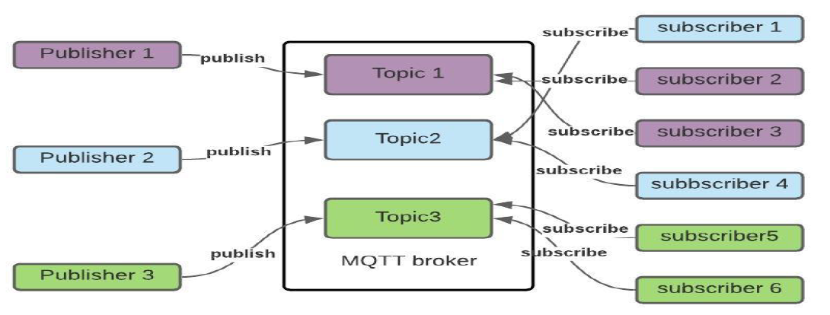

Fig 3.2.1 Structure of MQTT Protocol

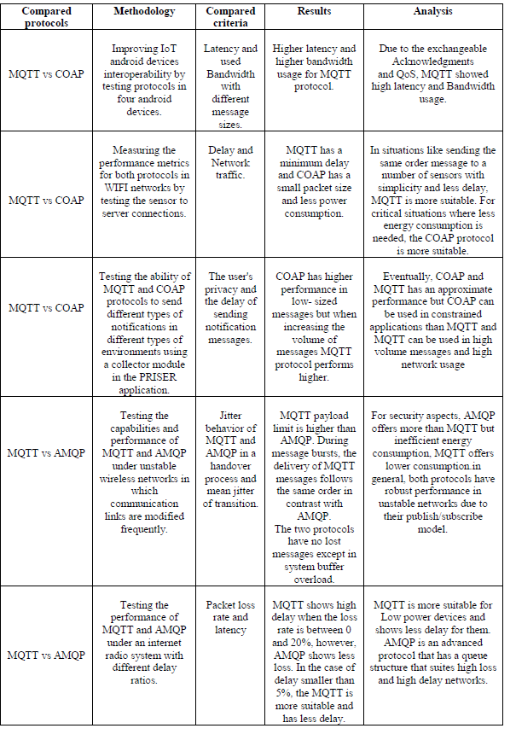Table 3.2.2 Comparison of MQTT Protocol with other IoT Protocol

**3.3 “IoT real time data acquisition using MQTT protocol”**

This study was done by implementing data acquisition using MQTT protocol and HTTP protocol and then by comparing the results of the two implementations. Its goal is to make the MQTT protocol more usable for temperature and humidity sensor data collecting systems that are interfaced with mobile and web-based apps.

The HTTP protocol is used to communicate across the Internet network (HyperText Transfer Protocol). Every day, various data, ranging from photographs to texts, is exchanged through the internet. As a primary protocol interface for moving data, HTTP has used a wide range of data from the server to user devices such as browsers fast, easily, and consistently HTTP stands for Hypertext Transfer Protocol. TCP is the foundation of the system. HTTP ensures that data is not corrupted as it travels from one device to another. Data transmission integrity is guaranteed. There are several devices that can access HTTP (Hypertext Transfer Protocol), such as web browsers and smartphones. HTTP may also be accessed through internet applications. An HTTP transaction consists of two components: a request instruction (request) sent from the client to the server and a response instruction (response) returned from the server to the client. A information block with a specific format called as HTTP Message is used to deliver the response and request procedures. The communications are sent through HTTP, which is a one-way protocol.

"Machine-to-machine" (M2M) communication is enabled through the MQTT protocol (Message Queuing Telemetry Transport). Because the MQTT protocol uses TCP/IP and has a small datagram size with a low overhead (less than 2 bytes), there is also a low power consumption. “Unlike client-server protocols, this method employs a publish/subscribe paradigm rather than a client-server model to transfer data in multiple formats, such as binary data or text, XML, or JSON.

MQTT provides 14 different forms of control signals, including:

* CONNECT — A client's request to connect to a server;
* CONNACK — A server's acknowledgment of the connection.
* PUBLISH — A message that denotes a new/separate publication.
* PUBACK — Quality of Service 1 in response to a PUBLISH message
* PUBREC — The first section of the QoS 2 message flow
* PUBREL — Part 2 of the QoS 2 message flow
* PUBCOMP — The final step in the QoS 2 message flow.
* SUBSCRIBE — A message that clients use to sign up for specific topics.
* SUBACK — A response to a SUBSCRIBE message.
* UNSUBSCRIBE – A message that clients use to unsubscribe from certain topics.
* UNSUBACK — A response to an UNSUBSCRIBE message.
* PINGREQ — Message from the heartbeat.
* PINGREQ — Message from the heartbeat
* PINGRESP — Confirmation of a heartbeat message
* DISCONNECT – Before disconnecting, clients provide a graceful disconnect message.

MQTT provides a QoS (Quality of Service) service level. This level confirms that communications are delivered in a timely manner. There is no effort to send a reply back whenever a Level 0 communication is sent. Level 1 messages are transmitted at least once to assure that if the subscriber does not distinguish (admit) the message, the broker will interact with the publisher to inquire about the customer's message acceptance status. Level 2 is in responsibility of ensuring that the communication was received. At this stage, it is possible to guarantee that information is provided while avoiding message repetition.. This study requires the following equipment to implement the MQTT protocol:

1. Wifi Module ESP 8266 & Wemos D1 Mini
2. Temperature and Humidity Sensor DHT 11
3. Use a PC server as a MQTT broker.
4. Smartphone with Android

According to the results of the test, the MQTT protocol is capable of transferring data six times faster than the HTTP standard. An option is to utilise MQTT for physical data processing real - world applications based on the Internet of Things.

**3.4 “Voice-Activated Home Automation using NodeMCU”**

This paper's outcome is a smart home automation system that uses voice commands. The lights and fans are turned on and off with a voice command using Google Assistant. The user issues the voice commands "turn on light 1" and "turn on fan 1," to which the Google assistant responds. If the light/fan is on, the Adafruit dashboard displays the value 1, and if the light/fan is off, the dashboard displays the value 0. The DHT11 sensor collects the room's temperature and humidity measurements and displays them on the Adafruit dashboard. The gas measured by the MQ2 Sensor is likewise presented.

The Internet of Things (IoT) is a growing technology that deals with the network-based linking of hardware devices and software applications. The home automation system allows you to control all of your household appliances right away. To obtain access to and control the devices and appliances, this article leverages a smartphone with the Google Assistant and a NodeMCU microcontroller with Wi-Fi (ESP8266) connectivity. It writes and uploads programs using the Arduino IDE, and it handles various data inputs using Adafruit IO, a cloud service.

The Node MicroController Unit, popularly known as the NodeMCU, is a hardware development board that is open-source. It contains the ESP8266 chip, which is a wifi module for connecting devices to the network. NodeMCU is a low-cost piece of hardware that can be used to build home automation systems.

The voltage and power are handled considerably better by the 4-channel relay module, which has 4 relays, than by the microprocessor. The sensor's analog signals flow via the multiplexer and are transformed to digital form by connecting it to the NodeMCU board's Analog to Digital Converter (ADC) input pin. The DHT11 is a low-cost sensor that measures temperature using the negative temperature coefficient. The MQ2 sensor is used to detect gases such as hydrogen, propane, methane, alcohol, and propane gas.

The Arduino IDE controls the circuit board until it is either turned off or reset. It is made up of two functions: setup () and loop (). The Arduino Integrated Development Environment (IDE) is a piece of software that allows you to build programs and communicate with your microcontroller. The C and C++ programming languages are supported in a reduced form.

There is a protocol called MQTT, which stands for "Message Queue Telemetry Transport," which is used for device communication. Support for it is provided by Adafruit's IO (Input/Output). Using the MQTT library or client, feed data can be transmitted and received. It is a cloud service that allows customers to keep several feeds of data in a single location. Over the internet, the Adafruit dashboard may be accessed from any location.

We command Google assistant with the hot keyword "Hey Google/Ok Google." The voice command is received by Google Assistant, which then converts it to data. The analyzed data is evaluated to see if the command is for IFTTT or another application. If the data is intended for IFTTT, the data is interpreted and sent to IFTTT. For example, we might say, "Hey Google, turn on Fan 1." The data is for IFTTT, and Google Assistant reads it as FAN 1=ON. FAN 1 = ON is then sent to IFTTT. If Fan 1 is on, then Relay2 is on, according to IFTTT. The Adafruit MQTT Server receives the interpreted data from IFTTT. The data is then shown on the dashboard and communicated to the Node MCU in the form of Relay 2 = ON. Node MCU checks for the appliance attached to the relay after getting data Relay 2 = ON. If the fan is connected, it will immediately turn on. Temperature and humidity are monitored using the DHT11 Sensor. The MQ Sensor can also be used to check air quality. The Adafruit dashboard shows the temperature and humidity readings.

**3.5 “Research of MQTT, CoAP, HTTP and XMPP IoT Communication protocols for Embedded Systems”**

This paper examines the most widely used IoT protocols for IoT embedded devices, as well as their benefits and drawbacks. This article describes the hardware stage utilized in this experiment, which uses Esp32 and the C programming language. It is critical to employ the correct IoT protocol, which dictates the system's purpose, hardware, and software. Because they address a wide range of requirements for a wide range of scenarios, there are many different IoT protocols.

With the advancement of automation systems, the usage of different connectivity and other specialized micro - controllers and embedded devices has increased. On Internet of things, there seem to be a range of communication standards and frameworks.. This is due to the entry of the so-called Internet of Everything (IoT) protocol into the industry. Designed Internet - of - things solutions can receive data from sensors modules, operate engines, machineries, relays, and other devices.

MQTT stands for Message Queuing Telemetry Transport. The Publish/Subscribe model is a transmission protocol designed for compact “Machine-to-Machine” connectivity. Each sensor acts as a client and communicates with a server in the MQTT architecture, which is based on a Client/Server concept. When employing TCP communication, the server is referred to as a broker. MQTT is a message-oriented protocol that publishes each message on a topic. There are a variety of subjects that customers may choose from while subscribing. All posts on a topic are sent to each subscribing client. The MQTT protocol in a nutshell. Client A, Client B, Client C, and Broker are shown. At some point, client A will publish a value. Upon receiving the communication, the broker transmits it to all clients who have signed up for the service.

In MQTT, there are three different service tiers. "Fire and forget," "delivered at least once," and "delivered exactly once" are three of the phrases. The broker can send a "last will and testament" message to MQTT customers if they are opt-out. Subscribers might receive these notifications when a device is unplugged. As part of MQTT, messages can be kept on the broker indefinitely. Customers can ask the broker to support their messages when they post them. Only the most recent and consistent message is shown. Any leftover messages will be forwarded to a client who has subscribed to a topic. MQTT brokers, unlike message queues, allowing stored messages to be preserved on the service is not supported.. Customers may be required to enter a username and password to connect to MQTT brokers for security reasons. To protect privacy, the TCP connection can be encoded with a Transport layer security certification.

Although different from  HTTP, CoAP is tailored to the demands of a small number of devices. Datagrams are being used to interact between client and the server. By removing the requirement for TCP, tiny microcontrollers can handle complete Internet protocol. For addressing, CoAP supports UDP broadcasting and multicast. The client/server paradigm uses UDP rather than TCP.

For communications that are centered and built on XML, the “Extensible Messaging and Presence Protocol” is being used. It is an open real-time communication platform that supports a variety of applications such as instant messaging, availability, a number of chat, sound / visual conversations, teamwork, lightwave, content, and generic XML data management.

This is the hypertext transfer protocol (HTTP), which ensures delivery dependability. HTTP specifies methods like GET, POST, PUT, DELETE, and others. It's solely meant for one-way communication between two machines at a moment. In most IoT applications, a huge number of connected devices are producing information at the given moment and wish to send it to the server as soon as possible..

For diverse IoT applications and objectives, there are a variety of current IoT protocols. When designers and program programmers are deciding who to utilise, having a thorough understanding of them is critical. The key IoT protocols and associated capabilities, as well as the hardware stage, software utilization, and categorization, are included in this article.

**3.6 “Gesture based IoT Light Control for Smart Clothing”**

A smart wireless bracelet is proposed in this paper. The possibilities of revolutionary gesture-based interactivity with linked lighting solutions are discussed. The solution is designed to provide a number of advantages, including increased dynamic interactive capabilities and ease of use. This work will be compared to existing solutions in a comparative analysis.

CoAP is a protocol for connecting smart devices to the Internet at the application layer. Because many components are resource constrained, variations in computing power and communication bandwidth must be addressed for a diverse set of devices. For M2M/IoT applications, CoAP has been tuned to be light and dependable. Instead of using TCP, CoAP uses UDP (or an UDP-like) protocol.

MQTT is a simple event and message-oriented protocol that enables asynchronous communication between devices. via a restricted network to faraway systems MQTT and CoAP have similar purposes, however they have different characteristics. MQTT uses TCP, whereas CoAP uses CoAP. Security is provided through TLS for UDP and DTLS for CoAP. A publish/subscribe mechanism is used by MQTT.

An open standard for real-time communication, the Extensible Messaging and Presence Protocol (XMPP) makes use of the Extensible Markup Language (XML) as its foundation. Essentially, XMPP is a protocol that allows entities to exchange short amounts of XML data in real time.

The existing method uses an intermediate processing PC, which limits real-time interaction, and even if the solution were created online, delays in the gesture would occur detection techniques, which are now set up in Matlab. As part of the We will be using an in the following step of implementation Using an Arduino-based microcontroller, you can turn on relays Using CoAP, you can turn on and off a lightbulb. In essence, the lightbulb will assume the role of a server, necessitating the use of a smart wristband to establish a connection as a CoAP client.

As an application of smart clothing, this study suggests a unique technique of controlling a light bulb based on CoAP. Gesture-based engagement has become more common as technology has advanced Interaction between people and electrical appliances of equipment has been shown to have a bright future. Users will benefit from the suggested device since it provides them with a traditional lighting control cannot provide a unique experience and our solution will improve the user-to-user interaction and more natural lighting Our future study will be focused on on symbiotic integration in smart homes and intelligent systems buildings, as well as providing improved lighting for the user By incorporating gesture detection processes onboard the smart clot, you may have a better experience.

**3.7 “A Review on IoT Light Control for Smart Clothing using Gesture Control”**

The lighting sector is being pushed to develop new means of control and interaction with lights by the Internet of Things (IoT). The term "connected lighting" refers to lighting that is connected to network infrastructure, most commonly wireless communications. Lights can be controlled by ubiquitous devices at any time and from any location. Methods of interaction based on gestures have developed as a viable option. Wearable systems in the form of smart clothes are being developed as a novel approach to operating gadgets via non-haptics ways. design human-machine interfaces that are interesting, convenient, and easy to use. We will be exploring the following topics in this seminar: a combination of various technologies in order to develop a holistic platform for simple dynamic interaction based on Cons.

The following literature survey was conducted to learn more about IoT Light Control for Smart Clothing using a Gesture Control method. The creator of demonstrated a wearable device that allows users to manage home automation frameworks using hand gestures. This product has several advantages over standard home computerization interfaces, including the ability to be used by people who have lost their vision, motor skills, or mobility. We can reduce the quantity and difficulty of gestures while maintaining functionality by combining various sources of setting with the pendant. The structure may check operators' actions for abnormal vibrations as they enter gestures. The goal of this project is to analyse, identify, and comprehend the movement of those who live in the house, resulting in a home that is aware of its occupants. These consciousnesses result in a living environment that can aid human occupants, anticipate their requirements, and restore their survival excellence. The signal-based regular human-robot interface, as described by the author in is a critical capability of the robot teleoperation framework. This interface not only enables clients to control a remote robot via display, but it also ensures simple collaboration and programming reusability in the construction of a well-organized robot framework. The use of a Kinect sensor for motion-based remote human-robot communication is proposed in this research. The signal recognition technique combines depth data with traditional Camshift following calculations using Kinect and employs HMM in a unique motion order.

This research proposes the use of smart clothes to monitor a light bulb using an advanced technique based on CoAP. Motion-based communication has proven to have a future of communication between users and electrical appliances or gadgets as a technological advancement. The proposed gadgets provide consumers with new information that outdated lighting controls cannot provide, and as a result, the dialogue between humans and lights will become more normal.

**3.8 “A Gesture Based Home Automation System”**

With the rise of IoT applications and the automation of everyday tasks, there has been a surge in demand for home help tools, however these voice-activated products are inaccessible to those with speech difficulties. Gestures are one method they could be able to communicate with the automation system. Gesturing is the process of giving commands to the system using various body parts such as the hands, fingers, face, and various combinations of these. Six gestures have been defined in the suggested model. Different finger formations are used to create these motions. Once you've mastered gesture recognition, you can move on to the next step. We may programme the underlying hardware device, which in our case is a Raspberry Pi 3B+, to send a GPIO pin to be active. A Python script can be used to automate the method described above. Python was chosen because of its diverse developer community, which allows for faster updates. The TFT LCD touch display allows users to engage with the gesture directory or settings in an interactive manner. The picture recognition technique employed is lightweight, allowing it to run on a range of hardware platforms. Espeak, a python-based text-to-speech package, is used to give the user audio feedback.

The steps for completing this project are as follows:

1) Capture, pre-processing, and recognition of images.

2) Obtaining data from sensors in order to carry out the task specified by the gesture.

3) Give the user feedback in the form of an automated voice.

PROPOSED WORK

1. FORMATION OF DATABASE

Correct images must be fed into the system's database in order for the system to successfully recognise gestures. The photos taken by the camera are compared to those in the database in the real-time recognition process. The image from the camera can then be used to create a database. Feature extraction processing can be done after segmentation and pre-processing.

1. IMAGE PROCESSING STEPS

Individual frames are created using the camera's real-time video stream. The RGB image is converted to HSV format as part of the image preparation. This is done to remove any extra information that may be present in photographs. In order to determine the region of interest (ROI) in the image, more edge detection is performed. Various filtering techniques, such as Gaussian or Median filtering, can also be employed to improve image identification performance. Following the feature extraction procedure, the image in the form of a vector may be compared to those in the database, and the proper gesture id established based on the degree of similarity.

CONCLUSION

The system recognises accurate gestures by utilising OpenCV for gesture recognition. The automation module, which interfaces IR, flame, and DHT 11 sensors, is able to successfully modify the sensors' states. The ‘text to voice' module is capable of converting the input test into speech, as well as providing a user-friendly manner for displaying the output.

The current system can recognise 5 separate motions that are numbers from 0 to 5, but in order for it to be deployed in the real world as a consumer product, it would need to include a larger number of gestures, which would require the system to complete a larger number of tasks. Controlling real-world appliances like tube lights or fans would necessitate the use of additional components such as relays and other circuits.

To improve the project's usefulness, motions can be captured using a variety of methods, including a dedicated camera or a mobile camera.

**3.9 “An IoT based Approach for Efficient Home Automation with ThingSpeak”**

This studies paper focuses to introduce an IoT primarily based totally method for green domestic automation device the use of Arduino and ThingSpeak. They have automatic nearly all of the crucial elements of a clever domestic. The device that they have got proposed is green with admire to low strength consumption, a boom withinside the existence of virtual home equipment and inexperienced building. They have made use of ThingSpeak cloud platform to combine the house components, procedure and examine the facts. MQTT protocol has been carried out for LAN communique. This paper has proven how existence can be simpler with the assist of IOT packages and digitalize the houses with admire of destiny IoT.

The proposed device has been made certain that it's miles low value and green tracking via way of means of using IoT primarily based totally gadgets and sensors together with Arduino UNO, Servomotor, Stepper Motor, Light Dependent Resister, Power Relay Board, ACS712 Current Sensor, Magnetic Sensor, Flame sensor, Water Level Sensor, Temperature Sensor, Soil Moisture Sensor, Gas Senso. Servomotors are carried out on doorways and home windows to fasten and manage their movement. Servomotor are used for controlling curtain however it isn’t shifting with precise torque. LDR’s are used to automate the mild to manipulate switches. Soil moisture sensors are used to test the parameters of soils surroundings and generate actual time effects via which selections are taken. Gas sensor are used to discover the presence of unique gases and their stage in surroundings. It has additionally been used to test the fueloline leakage in house.

Multiple Wireless Sensor Network protocols has been made to be had for facts communique and switch with exceptional protection functions and different parameters. ThingSpeak communique API is used for sensory facts communique. Data is transmitted over ThingSpeak API that's primarily based totally upon REST and MQTT protocol channel in each non-public or public manner. ThingSpeak communications study and write running time span is 15 seconds. The sensed facts is later analyzed at cloud and the real information are supplied thru cellular application. Fans, lights, curtains and door had been automatic on this project. The upgrades that may be completed on this paper are lowering put off time, including voice recognition, integrating biosensors inside domestic to manipulate air for higher health.

**3.10 “Smart Home System”**

Wide variety of components had been blanketed withinside the paper that consists of protection, electricity saving, air flow and clever kitchen. These components had been accomplished with the assist of clever gadgets which include faraway control, protection alarms, sensors etc. They have made positive that the identical is beneficial for elder human beings and people with disabilities for offering secure and steady environments.

Smart domestic community generation that they've made use has been categorized into primary types, wiring gadget and wi-fi gadget. In wiring gadget, they have got made use of recent wire, Busline, etc. In wi-fi gadget they have got divided into primary factors which might be sender and receiver. They controllers used withinside the task are tablets, smartphones, browsers and Short Message Service.

The clever kitchen applied includes Internet Refrigerator has been created wherein it permits customers to speak with it through Internet, so it can download recipes after which show them on its LCD screen. Also, the fridge is able to taking an automated stock of gadgets inner it and it could as nicely alert the customers to what's there. Microwaves are made to speak with clever fridges and recommend recipes primarily based totally at the meals gadgets to be had withinside the fridge. The microwave may even be set to begin at sure instances even as customers are far from domestic.

A case have a look at has been executed on a domestic withinside the task and has proved itself to lessen energy invoice through saving strength and has been represented on a graph too.

**3.11 “Home appliance control for users with motor disabilities using smart phone”**

The proposed gadget lets in someone with motor disabilities to manipulate the house home equipment with a unmarried contact at the android cell smartphone. This gadget has used GSM era due to its extensive variety of deployment in cell communication. The gadget structure has confirmed the interplay among an android contact display screen cell smartphone, PC (Virtual domestic), 8051 Microcontroller Kit, GSM, relay and digital home equipment. PC and cell smartphone are linked to GSM, Microcontroller, relays after which system is thru cables. The Virtual domestic offers an phantasm of digital home equipment in a regular domestic withinside the shape of buttons which adjustments its country upon contact at the icons gift withinside the utility established at the cell.

System Architecture - The utility containing the GUI for interplay with PC and GSM may be designed and established at the contact display screen cell. Depending at the icon touched at the cell display screen, corresponding equipment is both switched ON/ OFF thru GSM. GSM sends alerts to the 8051 microcontrollers in step with which suitable devices are operated. The relay circuit is essential to manipulate excessive voltage running devices, on account that a relay is successful to force excessive voltage gadgets with low voltage electricity supply.

The software program which can be used for the implementation of the proposed gadget are Eclipse Juno for android utility development, Eclipse Helios for designing digital domestic, Apache tomcat for interacting utility with digital domestic (Simulator), Keil software program for writing embedded C code essential for using the digital devices and this code is embedded into the 8051 IC the use of Flash Magic software program. The gadget proposed on this paper offers a person pleasant interface which includes a Touch display screen smartphone. By an unmarried contact of both motor challenged or regular human beings at the display screen, the digital devices may be operated. This saves electricity consumption, time and money, will increase convenience, contributes to economic system and additionally may be operated from out of station. The destiny paintings consist of addition of protection gadget, computerized door locks, temperature gadget, so they may be managed through a hand-held cell device.

**3.12 “Home automation system using android mobile phone”**

Home automation gadget created withinside the paper accommodates of Android cellular smartphone, DTMF Decoder, Relay driving force and AC hundreds. DTMF managed domestic automation works on DTMF generation which exists in Dial tone. DTMF tone has been generated through including or blending or greater frequencies. DTMF decoder has performed an vital position through the use of the MT8870D/MT8870D-1 that is a entire DTMF receiver along with each the band cut up clear out out and virtual decoder functions. The clear out out phase makes use of switched capacitor strategies for excessive and occasional institution filters.

The circuit diagram incorporates a DTMF decoder called MT8890 IC which converts dial pad tone into the 4 bit outputs..The Relay Driver has been made use to force stepper vehicles and deal with excessive cutting-edge hundreds the use of virtual circuits. The circuit diagram incorporates a DTMF decoder and named as MT8890 IC which converts dial pad tone into the 4 bit virtual outputs. Three LED’s also are linked at relay and 9V DC battery is likewise used for using LED’s. AC home equipment are managed through urgent dial pad keys like 1, 2,3,4,five etc.

The cellular smartphone is hooked up the use of auxiliary twine to the DTMF Decoder circuit. Q1, LIGHT is hooked up, at Q2 FAN is hooked up and at Q3 TV is hooked up thru relay driving force IC. Q4 is saved open. When key1 is pressed on the dial pad of cellular smartphone, DTMF decodes this tone and generates a virtual output given withinside the frequency table. This gadget is designed which implements the wi-fi generation which presents faraway get entry to from android phones. This layout presents the repute of current electric switches whether or not it's far became ON or OFF. This gadget makes use of DTMF generation which generates DTMF tone in line with key pressed in dial pad of android cellular smartphone and has proved green for antique elderly and handicapped person.

**3.13 “Home Automation System Embedded in an Internet-Of-Things Platform”**

The technique used withinside the paper incorporates of severa new views for current framework, as an addition to the ordinary with a clever grid that paintings easily it consists of facts accumulating from many reassets the usage of sensor conversation protocol, facts get entry to has been made secured and customized. Data is later up to date in web site at the Mobile APP. A demonstrator has been constructed and examined with purposely advanced Mobile App, zigbee, clever meter, allotted IOT server, gateways and bendy person interface. The gateway used guarantees an IP connection, to enforce the encapsulation of the nodes local protocol into TCP/IP packets.

The person aspect of the platform can speak on the utility stage at once with community nodes. The proposed paintings consists of a small mild weight Web server designed on Raspberry pi board, in an effort to make the device to paintings a whole lot quicker and primarily based totally on IoT technology. An strength meter is a tool that measures the quantity of electrical energy. Raspberry sends the cost of meter to computer the zigbee use to wi-fi switch of meter studying with the aid of using percent microcontroller. LCD presentations the cost of meter studying. All facts will replace on Mobile App in shape of web site as in step with modifications in tool parameter which include Voltage, present day and Power.

The software program is carried out with the assist of python coding and embedded C with the primary capability of boot loader is to initialize all of the gadgets which might be gift at the arm board. Mathematical Model at Server and Client has a area complexity this is depending on Presentation and visualization of observed styles. More the garage of facts extra is the distance complexity and time complexity that is depending on the No. of styles to be had withinside the database. They have provided the structure and demonstration of the Customer Domain of the clever grid, primarily based totally on a platform for the IoT that could host a extensive variety of clever domestic applications. It has specific blessings which include it's far patron centric, minimizes the deployment of particular clever grid and leverages possible.

**3.14 “Home Automation System (HAS) using Android for Mobile Phone”**

The method used withinside the paper is the one of the maximum well-known and green eras used for quick variety wi-fi communique this is Bluetooth which right here is used to automate the gadget which in flip eases the responsibilities of the usage of the conventional technique of the switch. It additionally highlights the factor that HAS gadget for Android customers is truly a step in the direction of the convenience of the responsibilities with the aid of using controlling one to twenty-4 extraordinary home equipment in any domestic surroundings.

Implementation steps concerned on this method is they first join Bluetooth directly to the cellular phone. Then we need to open the ‘HAS’ utility. Next, we need to pick join tool alternative in ‘Bluetooth Serial Module could be to be had under’ section. Now we need to pair ‘Bluetooth Serial Module’ with the aid of using supplying pair code. Now we are able to begin with the aid of using choosing specific tool for making ‘ON/OFF’ operation from List Menu so one can be displayed. Home Automation System has been advanced the usage of android platform the usage of gadgets with Android aid with the Bluetooth connectivity This utility has proved to be a benefit for the ones customers longing to make their residence an automatic domestic. Home equipment are being managed the usage of this interactive utility withinside the domestic surroundings easily. They have used expandable listing view to organization listing facts with the aid of using extraordinary sections of the residence.

When the consumer touches the header, the gadget has the functionality of increasing and collapsing the groups. The end of the paper specializes in the purpose of the motive of the gadget to apply cellular phone’s in-built Bluetooth facility for automation without the usage of the Airtime. Entire utility software program on this task has been designed the usage of Android, Bluetooth API and C Language. They have examined HAS utility application on numerous android cellular phones. The consequences are provided withinside the paper are pretty satisfactory. The has been proved that the HAS furnishes an excellent paradigm for any Automation System primarily based totally on Android Mobile Phone and Bluetooth. List of android gadgets on which HAS Application examined are Samsung Galaxy, Duos, Micromox Bolt and plenty of more.

**3.17 “Accelerometer based data glove for blind and dumb”**

The approach used in the paper is to try bridging the interaction gap between the blind/dumb or any physically handicapped person and a healthy person. Here a data glove with an accelerometer sensor is used to capture the gestures. Then it analyses the motion using controllers and later generates an email containing a predefined image which is in the context of gesture as an attachment. Also, the hand movement is detected and converted into a output of the format of voice.

The paper aims towards the blind and dumb jointly participating in the digital activities just like the other normal human being does. The proposed methodology is a accelerometer sensor (adxl345) is interfaced with Node MCU Wi-Fi module (esp8266) with the help of jumper wires. on the data glove. The glove is wearable which has both of these hardware components are fixed and the user has to don the glove so that his/her gestures are recorded. Accelerometer helps in providing orientation based acceleration values and that is of all the 3-axis. All the sensor data gets transferred to Raspberry pi with the help of NodeMCU. The script is uploaded on NodeMCU using Arduino IDE and it has the details to communicate with Raspberry Pi in accordance with MQTT protocol. The software Interfaces that are used in building this system are Python IDE (PyCharm), Arduino IDE, Raspbian OS for Raspberry pi, Putty, Advanced IP Scanner, Raspberry pi Disk Imager, Etcher and Firebase.

The end of this paper is that the proposed prototype facilitates visually challenged and mousy humans to speak with the society simply because the everyday human beings. The proposed device is constructed with the motto to take signal language as enter and convert it and supply a voice output and additionally a textual content to predefined photographs thru e mail to that unique person. This device is efficient, dependable and additionally clean to apply because the circuitry could be very simple.

The destiny enhancement with admire to this paper is to feature research with a particular stop purpose to create a progressed shape of the framework this is proposed. Framework might be constructed with the functionality to carry matters in each heading through exactly understanding the yield from a given unique element only. It will have the cap potential to make an interpretation of normal local language to deal with the alerts extra effectively. The photograph managing a few parts of the framework also can be altered identical manner to paintings with each condition. A take a look at might be brought to understand symptoms and symptoms that encompass such gesture. We also can upload a segment to offer help in phrases of using generation and additionally programs like Google Assistant. English language-primarily based totally voice output may be generated after analyzing out for Braille script or report with glove.

**3.18 “A High-Security and Smart Interaction System Based on Hand Gesture Recognition for Internet of Things”**

They have constructed a machine that is a vision-primarily based totally hand gesture reputation machine. It gives high-protection and additionally a clever node is introduced withinside the software layer of Internet of Things (IoT). The machine that they've constructed may be mounted into any tool which has a monocular camera. It can have interaction with many customers after spotting pointing gestures from the pix that gets captured. The statistics with recognize to the interplay allows in reaching each real-time and real records communique as its being decided through a immediately line from the consumer’s eye until the end of the index finger.

This machine includes particularly modules. The first module that is an area repair-primarily based totally hand subpart segmentation set of rules allows in combining pictorial systems with area statistics and extracts hand areas from complicated backgrounds. The 2nd module is placed through an adaptive approach. They have advanced a vision-primarily based totally interplay machine. It makes use of a pointing gesture reputation withinside the software layer of IoT thinking about it as a node. When a specific consumer factors toward the display, a immediately line from the attention to the fingertip allows to decide the location at the display wherein the cursor must be placed. Firstly, 2D pix are captured with the assist of a ordinary camera. Secondly the consumer’s eye is detected through the AdaBoost classifier that is primarily based totally on Haar-like features. Thirdly the hand vicinity withinside the captured photo is segmented out from the complicated backgrounds with the assist of area repair-primarily based totally segmentation set of rules. Detection of the fingertip of the index finger is achieved through combining each the convex hull and additionally convexity disorder features.

An adaptive approach of pointing course estimation is proposed if each the attention and the hand are placed to reap the pointing role consistent with the attention-finger tip line. Finally, the cursor is positioned to the pointing role. The machine can handiest be activated while the attention and hand of the consumer are each detected as a result its steady and real. The end of the paper is that the interplay among human and laptop ought to be activated through the presence of each eye and hand.

This machine allows in combining the pictorial shape version and hierarchical chamfer matching set of rules as they have got hired hand segmentation set of rules wherein curve becoming that section hand areas is achieved correctly and additionally efficiently. Also, they have got proposed an adaptive pointing course approach for estimating the cursor calibration. An adjusting method is customized to accurate the offsets which can be used among the goal role and the calculated role. The end result of the approach suggests that the proposed machine gives a herbal and pleasant human laptop interplay which offers accuracy of cursor positioning beneath complicated backgrounds.

**3.19 “Voice Controlled Smart Home”**

The technique used withinside the paper accommodates of a voice-managed clever domestic automation gadget that has been advanced and additionally carried out with the assist of the approach of OpenHab framework. OpenHab withinside the back-cease offers a platform that allows to consciousness us on blending numerous forms of clever gadgets and technologies. The intention of this gadget constructed is to manner the improvement of a sensible, modular and flexible domestic automation answer as maximum of the clever gadgets nowadays own differing conversation protocols. This gadget integrates voice through OpenHab which makes use of Google Voice Assistant and controls the gadget cloud connector. Protocols are used to combine exclusive gadgets with exclusive conversation protocols. It makes use of MQTT protocol to feature sensors to Node MCU because it maintains an eye at the ambient situations of the room.

OpenHab is a open Home Automation Bus. For the all the smart home devices at home it is a central home automation platform. The core of this model and also the one which acts as a server is a central controller. It is considered as the central part of an IoT system. If the central server is down the entirety of the system is down. Many types of devices are connected to the server. Out of which some of them will be capable of communicating with each other considering the fact that they have the capability to do so. But as there is centralized control and troubleshooting it is always considered a better approach to avoid it. We can use the server as a central controller in case there is a occurrence of an error. OpenHab helps in facilitating a big deal so as to communicate with all other devices. It also integrates them to the central server. System architecture contains three parts which are OpenHab Server, MQTT appliances and Google Voice assistant binding.

The overall result of this paper is Interpretation of Communication protocol, User Interface of the system, Controlling voice through Google Assistant. The conclusion is that they are successful in being able to build and deploy a voice-controlled smart home system. It is dependent on the OpenHab Framework. Its main features are that the system can be deployed in houses itself. The system can effectively use the wireless network system placed within the house. Its is suitable to make changes to facilitate multiple smart home appliances. The system has a central controlling device or a central server that is responsible control and monitor all the smart home appliances. This prototype works on low powered appliances. Further development for the usage of Smart appliances can be done and also in security cameras can be integrated into this system.

**3.19 “Arduino Based Home Automation System Using MQTT Protocol Incorporating Internet of Things”**

The method used withinside the paper incorporates the concept of enforcing the house automation machine thru net of factors primarily based totally on Arduino that's interactive to degree temperature, smoke, mild and intrusion. This mission is successful to steady domestic and additionally lessen the wastage of water or energy. This mission uses the MQTT (Messaging Queuing Telemetry Transport) protocol as it's far a secure and secured protocol. It is working on pinnacle of TCP protocol and is a publish and subscribe primarily based totally messaging protocol. These days there are domestic automation machine structures which gather statistics from the sensors and home equipment with the assist of wi-fi technology and IOT technology inclusive of commercial-of-the-shelf (COTS).

A domestic automation machine is designed for tracking and controlling gadgets. There is a popular domestic gateway which collects facts from family gadgets that's taken as enter from the consumer and later it in an IP community surroundings it relays the consumer’s manipulate instructions closer to family gadgets. The blessings of this machine are the sensor networks are programmed with numerous consumer interfaces appropriate for consumer of various cap potential and for professional customers in order that the machine is maintained without problems and additionally interacted with easy terms.

The machine advanced is powerful and consequently operates very flexibly. Performing the tracking remotely and controlling home equipment efficiently are the traits of the machine. It is straightforward for the neighborhood and far off consumer interfaces to deal with through a beginner purchaser with which operations are dealt with efficiently. Appliances which might be related through clever sensing devices and managed through automation which might be primarily based totally at the tariff situations and through the inhabitant domestically the use of GUI remotely the use of the internet site primarily based totally at the inhabitant usages.

The problem or downside of this precise machine is that the strength intake manipulate mechanism is restrained to best positive gadgets as mild illumination however numerous family home equipment viable to managed. The strength is managed primarily based totally on constant threshold strength intake which may not be relevant to specific consumers. In education inhabitant necessities may also range in step with their behaviour however now no longer with community traits for the manipulate of domestic home equipment thru community control function. And right here as there isn't even a unmarried machine that has taken variable tariff of energy into attention that's ate up in the course of the day and night.

1. **METHODOLOGY**

The suggested method will allow users to execute downloaded software on any mobile device, such as smart phones or mobiles, using any android-enabled device and smart watch. The user will be able to handle or run a gadget with this home automation system such as light and fan that is connected at various intensities with the help of Wi-Fi.

We have come up with a wrist band which can take inputs such as hand gesture movements with help of an accelerometer. With the help of google assistant we take our voice as input and a slide movement of a sliding bar in ubidots server. System recognizes these inputs and data is published with the help of Node MCU via MQTT Broker which is then subscribed with the help of an another Node MCU at electric devices.

**4.1 MQTT PROTOCOL**

“MQTT abbreviates to Message Queue Telemetry Transport”, communication protocol that allows network clients to easily share telemetry. This protocol is ideal for low bandwidth environments and IoT devices with extremely high latency. This protocol specializes in Machine-to-Machine (M2M) communication. A TCP/IP stack is used to operate this communication protocol. MQTT was designed as a low-overhead protocol to get around bandwidth and Processor constraints. It was created for use in embedded devices, where it may provide a constant, reliable, and dependable channel of communication. MQTT is a great option for wireless networks that have sporadic degrees of inactivity owing to bandwidth limitations or unstable connections. The protocol is used in a variety of sectors, including automotive, energy, and telecommunications.

The MQTT protocol states two types of network objects: a message broker and several clients. The clients are further classified as a Publisher or Subscriber. The client-server design and MQTT's publish/subscribe (pub/sub) communication paradigm are quite analogous. The client that communicates is referred to as the publisher, while the client or clients who collect the information are referred to as the subscribers in the publisher/subscriber paradigm. When the client is sending the data, it is called Publish and the receiving is called as subscribe The brokers take care of the communication between the Publisher and the Subscriber.

A MQTT broker is a server that collects and passes all messages from the Publisher to the Subscriber. The MQTT broker is the hub of every publish / Subscribe protocol. According on the configuration, a broker can manage thousands of MQTT customers. The broker is responsible for sending and receiving all messages, filtering them, identifying who has subscribed to each information, and then delivering the message to those who have subscribed. The broker keeps track of all ongoing customers' transactions, involving subscriptions and ignored messages. Client authentication and authorization are among the broker's other duties. The broker is often extendable, permitting for customizable verification and backend system interaction.

A MQTT session consists of four main phases:

* Connection
* Authentication
* Communication
* Termination.

A client establishes a Transmission Control Protocol/Internet Protocol (TCP/IP) connection with the broker by using either a standard port or a special port established by the broker's administrators. 1883 and 8883 are the default channels for plaintext and encoded communication, respectively. Secure Sockets Layer (SSL)/Transport Layer Security (TLS) (TLS) is employed for secure messaging.

MQTT is regarded as a lightweight protocol since all of the packets have a tiny code footprints. Each transaction has a two-byte fixed preamble, an optional variable header, a 256-MB message content, and a quality - of - service (QoS) level.

MQTT messages are organized into topics. It is not necessary to configure a topic; simply posting on it is sufficient. Topics are organized into a hierarchy and separated by a slash (/). This, like a filesystem, allows for the creation of a sensible grouping of common themes.

Three levels of service quality are given by MQTT (QoS). The Quality of Service (QoS) identifies how aggressively the broker/client will work to make sure that an information is transmitted. Clients can subscribe to topics at any QoS degree, and communications can be sent at any QoS level.This implies that the client selects the highest level of QoS that it will receive.

Higher QoS levels are more trustworthy, but they also need more time and bandwidth.

* 0: The communication will be delivered only once by the broker/client, with no confirmation.
* 1: The message will be delivered at least once by the broker/client, with confirmation necessary.
* 2: Using a four-step handshake, the broker/client will deliver the message precisely once.

The MQTT protocol architecture's lightweight qualities and low overhead assist assure seamless data transmission with minimal bandwidth while lowering CPU and RAM consumption. Higher QoS tier are more trustworthy, but they require more delay and bandwidth.

The following are some of MQTT's advantages over rival protocols:

* Because it is a lightweight protocol, it is both efficient and quick to install.
* Due to the reduced number of data packets, network utilization is low.
* Efficient data distribution.
* Distant sensing and control are successfully implemented.
* Delivery of messages in a timely and efficient manner.
* It uses very little power, which is good for the connected devices..
* The bandwidth on the network has been optimised.

**4.1.1 Setup of MQTT broker using Ubidots**

Ubidots is an Internet of Things (IoT) platform that allows innovators and businesses to prototype and expand IoT applications to production. From any Internet-enabled device, use the Ubidots platform to transfer data to the cloud. After that, you can set up actions and alerts based on your real-time data and use visual tools to uncover the value of your data. Data sources, variables, values, events, and insights are all accessible using Ubidots' REST API. An API Key is required for the API, which supports both HTTP and HTTPS.

The following steps are to setup MQTT broker on the Ubidots cloud:

1. Create an account on the Ubidots website.

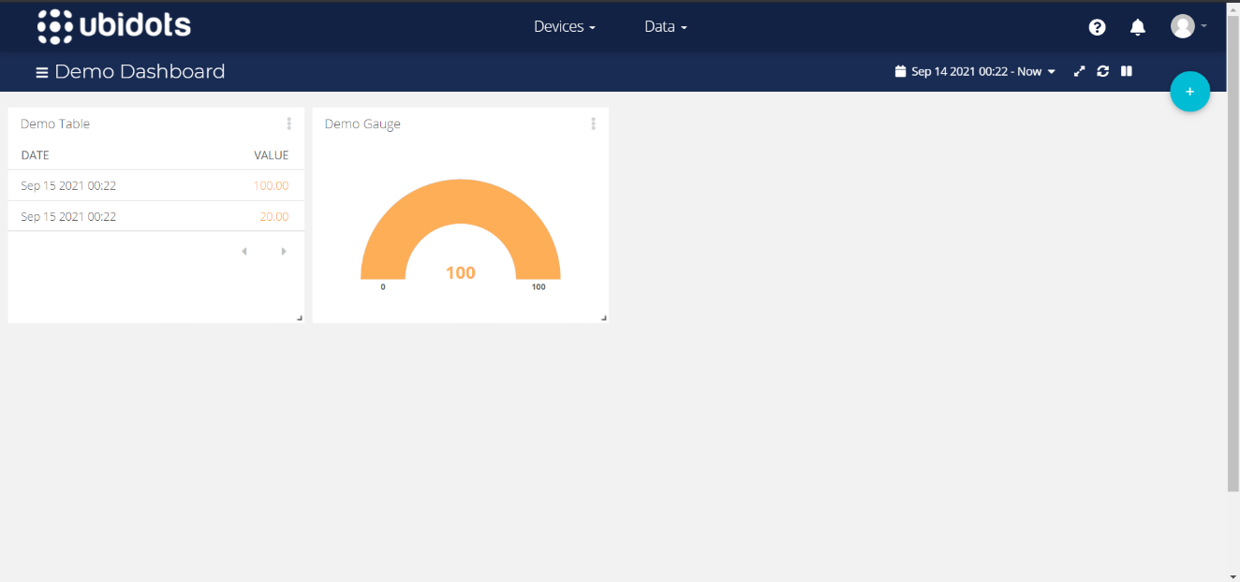Fig 4.1.1 Ubidots Website (Dashboard)

1. From the Dashboard, select Devices to display a drop-down menu of options.
2. Click on devices again.
3. Hover your mouse over the '+' icon on the right side of the screen, then click the smaller '+' icon.

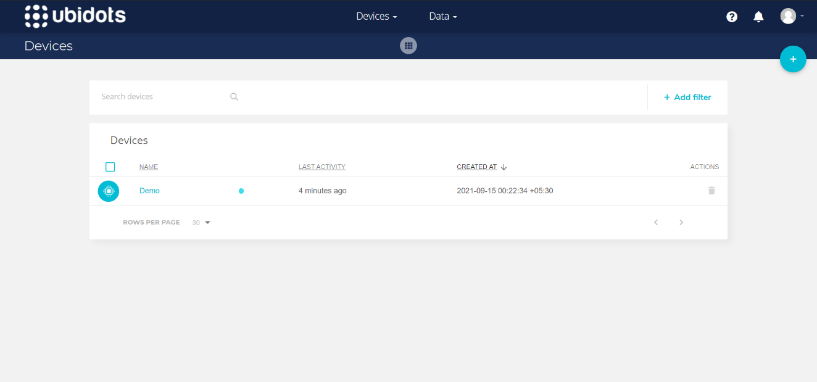Fig 4.1.2 Ubidots Devices

1. Select the "blank device" block. Fill in the device name and label fields. You have successfully created the device.

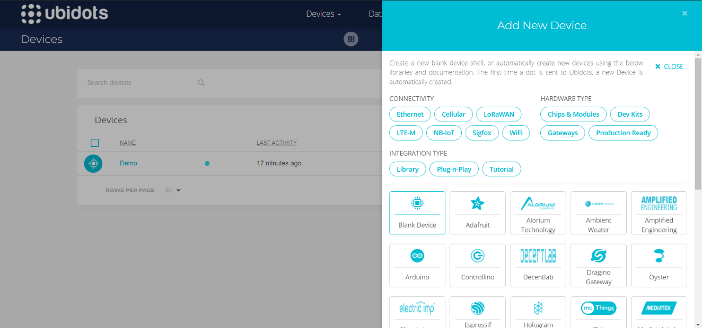Fig 4.1.3 Adding a new device (1)

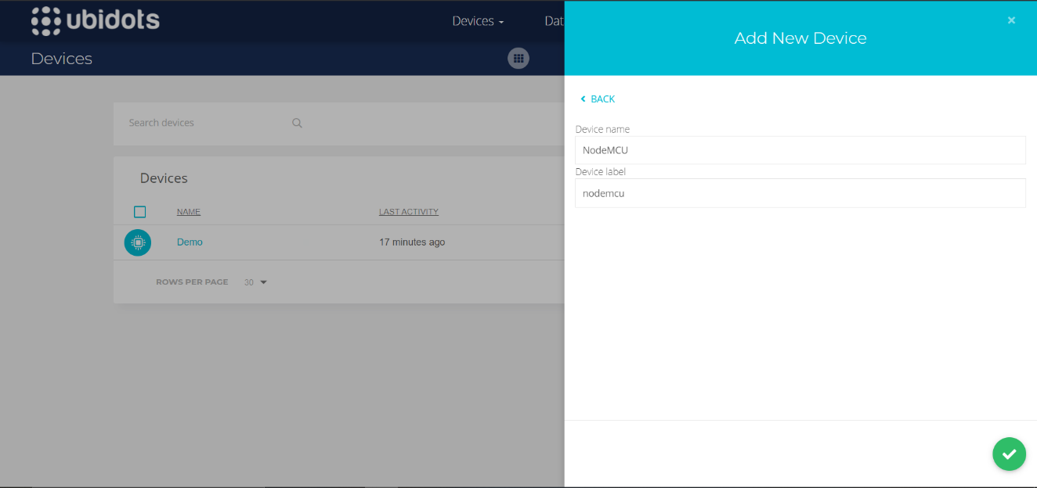Fig 4.1.4 Adding a new device (2)

1. Select the newly created device from the devices list.

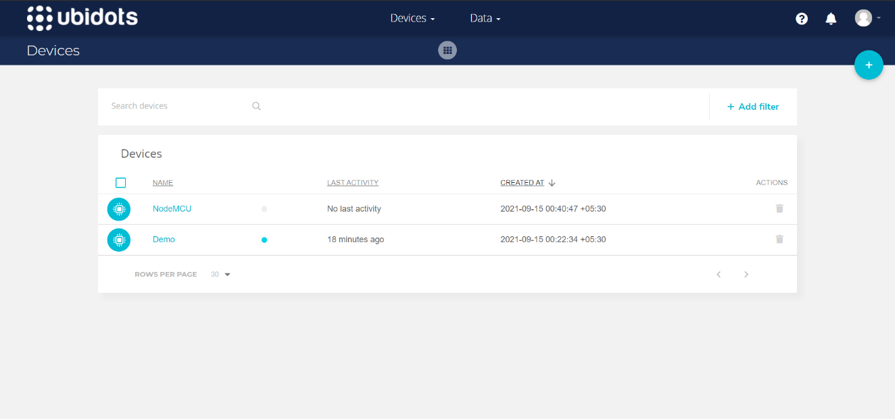Fig 4.1.5 Selection of new device from the device list

1. Select the 'Add Variable' block, then the 'Raw' option. Assign a name to this variable. A notification should appear that says "Variable Successfully Created."

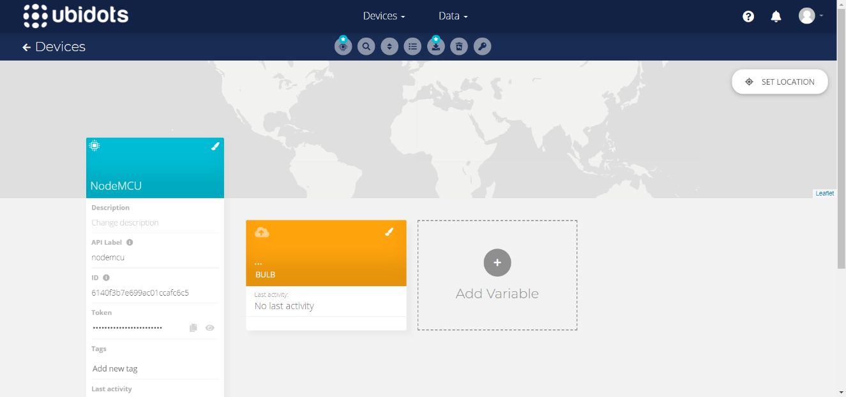Fig 4.1.6 Adding a new variable

1. Return to the dashboard. To select a widget, click the ‘+' icon and select the widget you want. I chose the slider option to give the appliance a slider control.
2. After you've chosen the widget, go to ‘+ add variable' and choose the newly formed device. Then select the variable you just made.

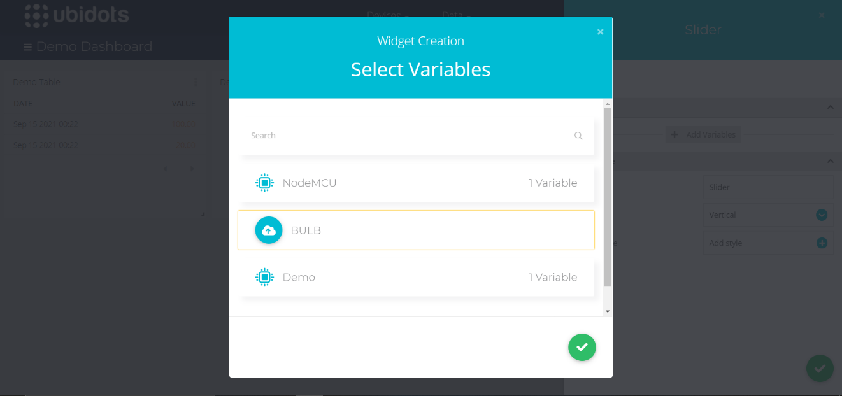Fig 4.1.7 Selection of variables

1. To build a widget, fill in the widget's fields and then click the green tick in the bottom right.

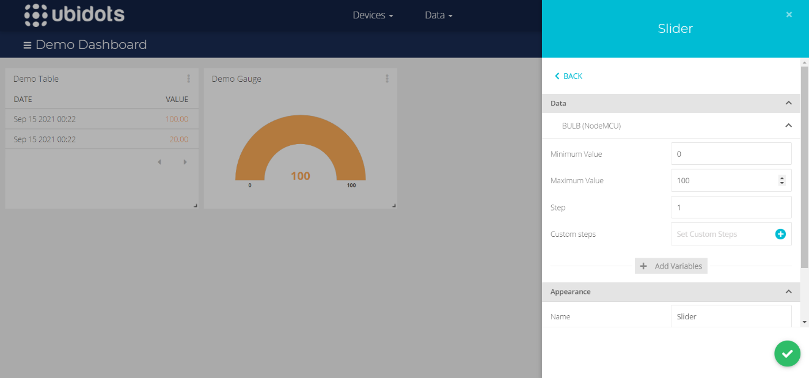Fig 4.1.8 Adding widgets to the Dashboard

1. You've set up your MQTT broker. The appliance's parameters can be controlled and monitored.

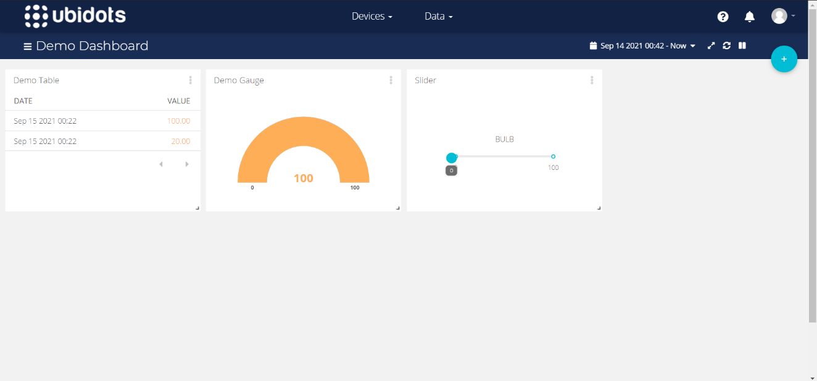Fig 4.1.9 Setup of Ubidots Dashboard for MQTT broker

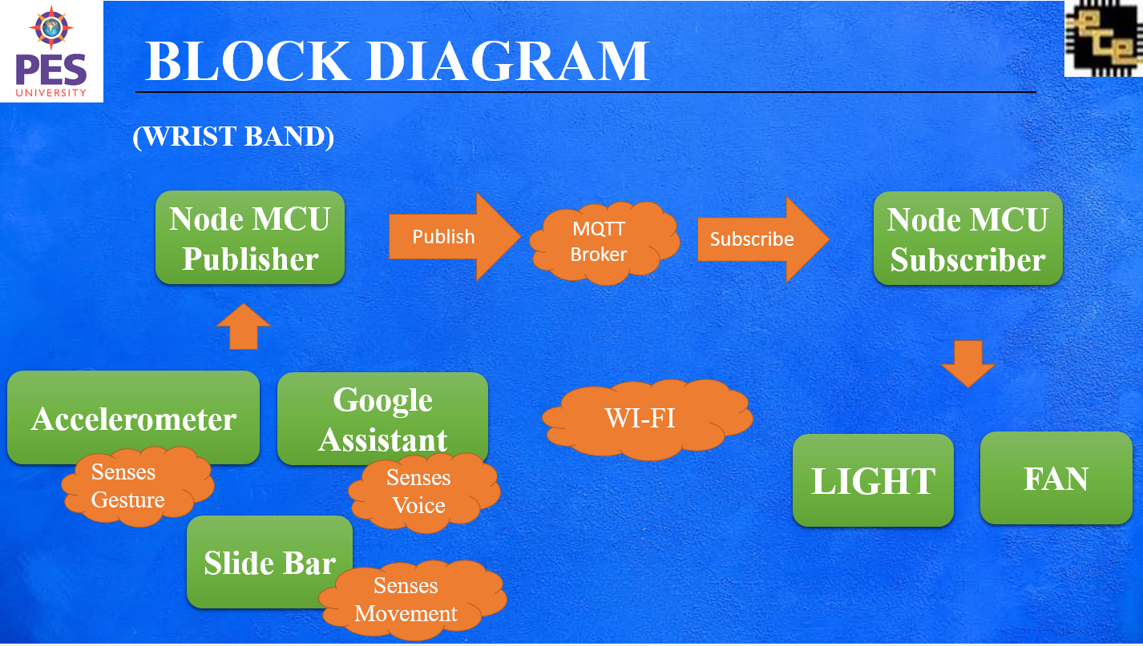Fig 4.1.10 Block Diagram of the proposed idea

**4.2 THE SUBSCRIBER CIRCUIT**

The Subscriber circuit is the main circuit that is responsible for controlling AC voltage. This circuit is a microcontroller-based circuit, where the microcontroller used is NodeMCUThe NodeMCU (Node Micro Controller Unit) is an open-source hardware & software programming platform based on the ESP8266, a low-cost System-on-a-Chip (SOC).The NodeMCU has inbuilt WI-FI support with TCP/ IP protocol.

With the aid of NodeMCU, this circuit is connected to the internet through WI-FI. It receives data from the MQTT server or the cloud. Upon receiving these data, the circuit controls the various appliances connected to it. The method used for controlling the AC voltage is the Leading-Edge Phase dimming method.

The circuit is split into two sections:

1) Circuit with a Zero Cross Detector

2) Triac-based phase/angle control

**4.2.1 zero Cross Detector circuit**

To regulate the AC voltage, the first thing we need to do is identify the AC signal's zero crossings. The AC signal frequency in India is 50 HZ, and it is alternating in nature. As a result, whenever the signal approaches zero, we must use the Zero-Crossing Identification Technique to identify that position. The dimmer is synchronised using zero-crossing.

The current is limited by two 47k Ohm resistors. We must detect when the value changes from positive to negative or negative to positive and coordinate our pulses accordingly so that it fires in the same location every time. We'll use a full bridge rectifier for this. This will produce both positively and negatively AC input curves as output. The Bridge rectifier is rated 1000 Volts and 1.5 Amperes. The output of the Bridge Rectifier is then connected to a Phototransistor Optocoupler MCT2E. It has a transistor that is operated by light, as the term "phototransistor" implies.This IC has an Infrared (IR) led and a phototransistor inside it. The Optocoupler isolates the high and low voltage sides of a circuit. When the output from the bridge rectifier is high at the MCT2E, the IR led turns on. This light falls on the phototransistor, which results in the conduction of current from the collector terminal to the emitter terminal. Pin 5 of the MCT2E is connected to the 5v DC source with a 10K Ohms pull-up resistor and is also connected to the D6 pin of the NodeMCU. Pin 4 is connected to the ground pin of NodeMCU.

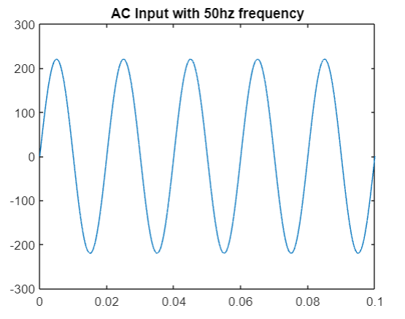

Fig 4.2.1 AC Input with 50Hz frequency

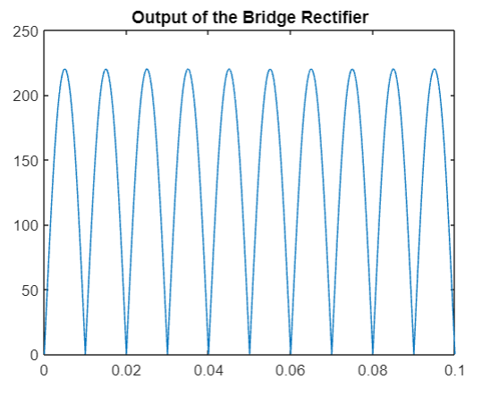

Fig 4.2.2 Output of the bridge rectifier

When the transistor conducts the current, the output at pin 5 is pulled down to 0. The input at the D6 pin of the NodeMCU receives a digital LOW. When the output of the Bridge Rectifier passes through the zero points. The IR led of the MCT2E is off. This results in an open circuit of the transistor. The output of pin 5 is pulled up to 5v. The input at the D6 pin of the NodeMCU receives a digital HIGH.

The above operation results in the generation of pulses every time the AC signal crosses the zero value. For an AC signal having 50Hz as its frequency, one cycle has a duration of 20ms. The signal crosses the zero value at the half cycle which is 10ms. So this generates pulses every 10ms.

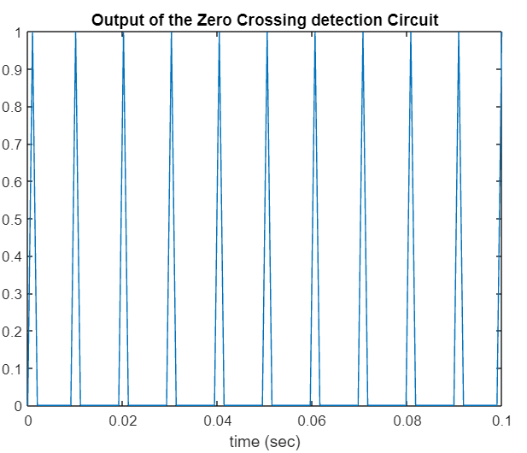

Fig 4.2.3 Output of Zero Crossing detection Circuit

**4.2.2 Phase/Angle control using Triac**

The phase/ angle control using Triac is the second part of the subscriber circuit. This circuit mainly includes a Triac BT 136 and an optocoupler MOC3021. Triac is a semiconductor device that is abbreviated to Triode AC switch. It is 3 terminal electronic device that is bidirectional that can conduct current in both directions depending on the gate signal being positive or negative. Triac is a part of thyristor devicesIn AC control applications, triacs are employed. They can convert high voltages and currents, as well as the positive and negative cycles of an AC waveform, over both sections. Triac circuits are therefore well fitted for a variety of power switching applications. This Triac needs a driving IC. For this MOC3021 optocoupler is used. The specialty of the MOC3021 is its Zero Crossing capabilities.

One end of the Triac is connected to the bulb and the other end is connected to pin 4 of the MOC3021 IC. The gate terminal is tapped into the connection between pin 5 of the MOC3021 and the AC source. There is a 330 Ohms resistor between pin 5 of MOC3021 and the AC source. The pin1 of the MOC3021 is connected to the to D2 pin of the NodeMCU. There is a 330 Ohms resistor connected between them. This connection is the Triac output. The pin2 is connected to the ground pin of the NodeMCU.

Considering the output of the zero-crossing circuit, we generate pulses every 10ms. To control intensity we need to fire Triac between the interval 0ms to 10ms. But rather than choosing the extreme values, we will choose a safe interval that is from 0.2 ms to 7.2ms considering the delay time in NodeMCU. To decide what time the Triac should be fired, we consider the zero-crossing voltage as the reference. Now depending on our input, we provide power to the bulb for a certain amount of time. For example, we want the bulb to be turned on for 50% of its total brightness. So we provide power only for half of the half-cycle that is for 5ms. With the zero-crossing point as the reference, the power is provided to the bulb after 5ms after it passes the zero point.

This operation is done by controlling the gate pin of the Triac. When the gate pin of Triac is fired, the AC current flows through the Triac. So, depending upon the brightness we want to achieve, the Triac’s gate pin is turned off or on for a particular duration. The higher the brightness we want, the duration of firing the gate will be lesser. The lesser the brightness, the more the duration of the firing of the gate. This basically controls the phase of the AC wave.

The approach is known as leading-edge phase dimming because it uses a current that is shut off as the AC waveform begins, immediately after it passes zero.

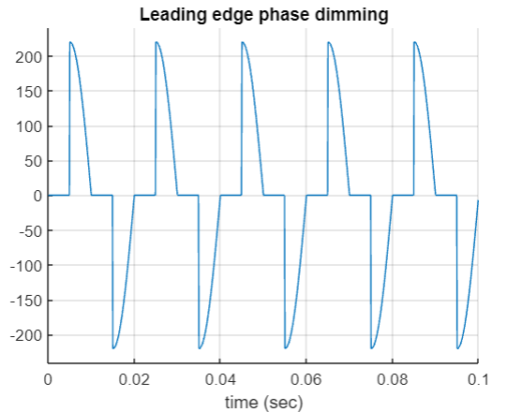Fig 4.2.4 Output of the AC wave with Triac control

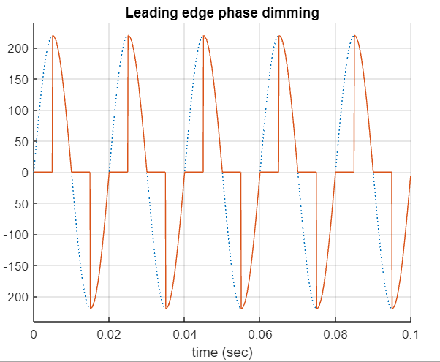

Fig 4.2.5 Comparison of AC wave with the output of leading phase edge dimming

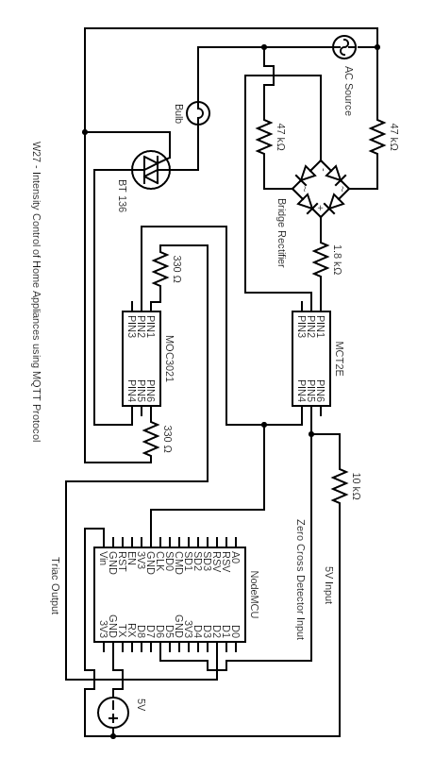

Fig 4.2.6 Schematic of the Subscriber Circuit

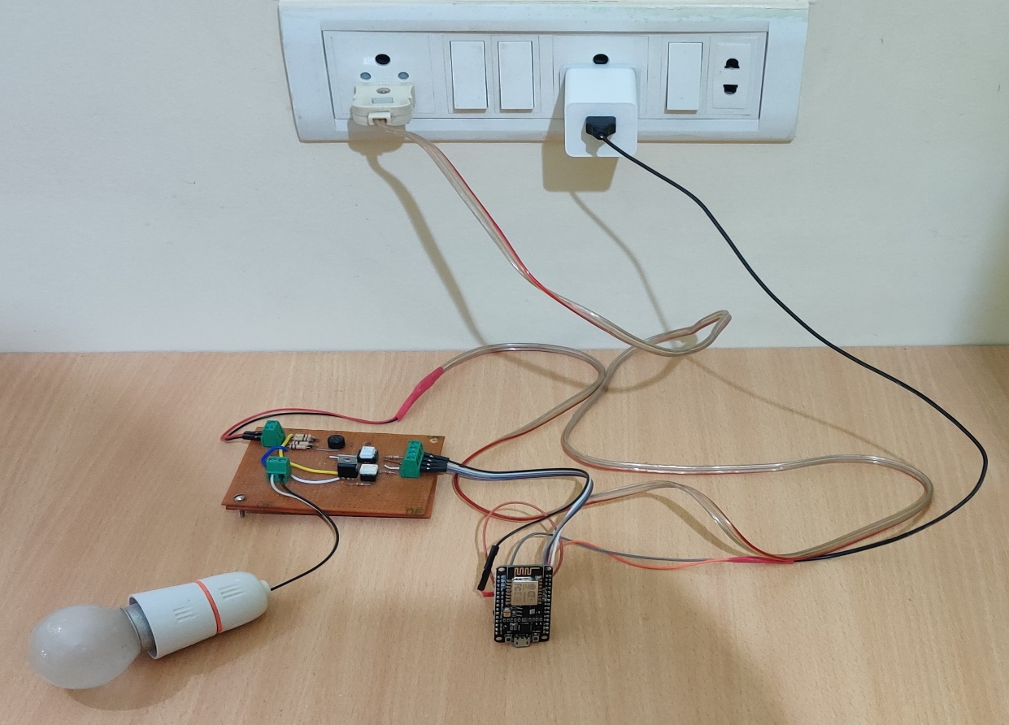

Fig 4.2.7 Setup to demonstrate the working

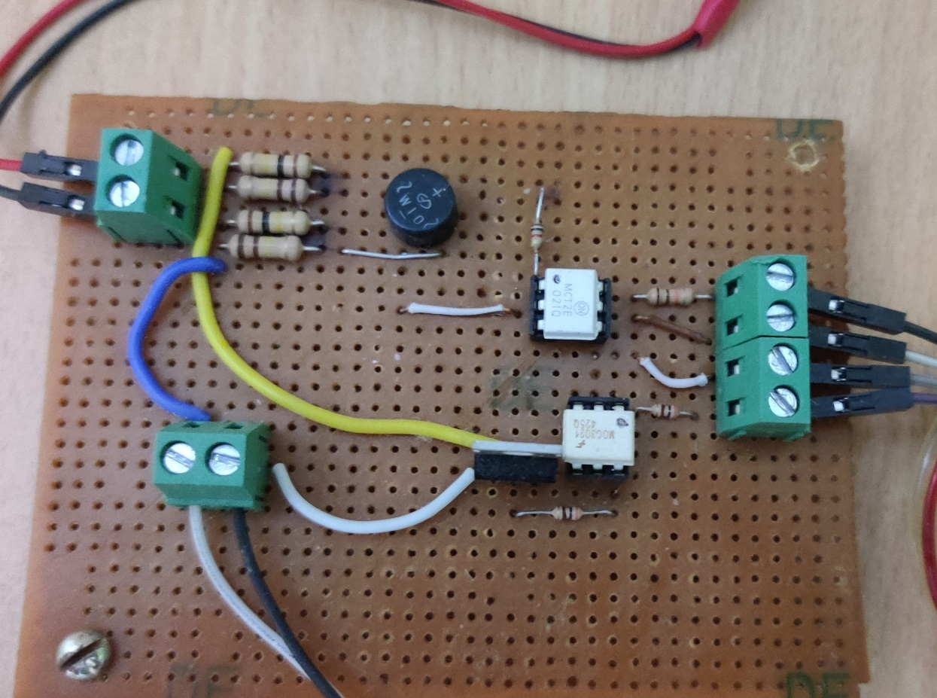

Fig 4.2.8 The Subscriber Circuit

dad

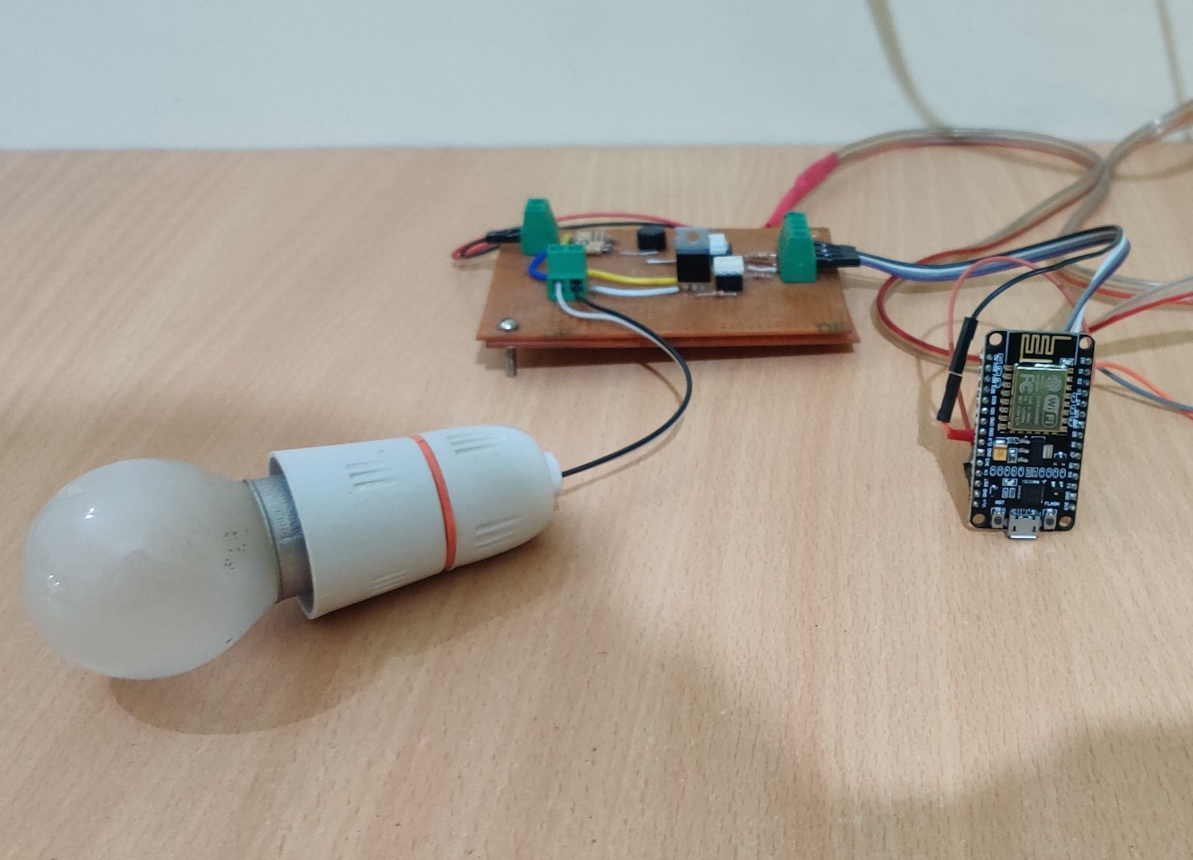 Fig 4.2.9 The side view of the Subscriber Circuit

* 1. **GESTURE-BASED WRIST BAND**

The gesture-based wristband mainly consists of NodeMCU and a sensor moduleMPU-6050. To power the wristband, we have used a 18650 lithium-ion battery which has a capacity of 1200 Mah with a voltage rating of 3.7V. As the NodeMCU needs a minimum of 5V to be powered on, we used a step-up power module to convert 3.7V to 5V to power on the NodeMCU and MPU-6050 sensor module.

“MPU6050 is a 6-axis Motion Tracking Device with a fully functioning sensor module”. A three - axis gyroscope, three - axis accelerometer, and a Digital Motion Processor are all included into a compact device. It also features an on-chip temperature sensor as an extra function. The I2C serial communication protocol is used by the MPU6050 to connect with the NodeMCU. I2C links several slaves to a single master (similar to SPI), and numerous masters can operate one or more slaves.

Data is sent between devices using only two wires in I2C:

* SDA (Serial Data) - This is the data transmission channel between the master and slave
* .Serial Clock Line (SCL) — This is the line that carries the clock signal.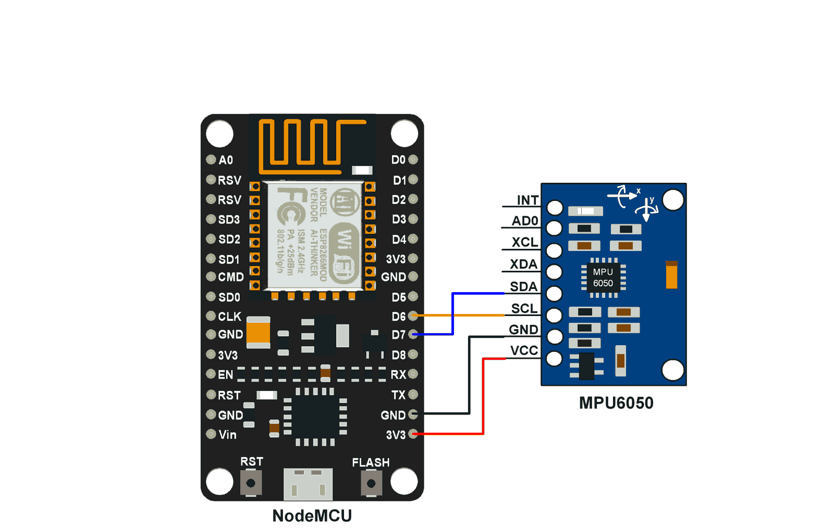

Fig 4.3.1 Connections between NodeMCU and MPU6050

The SDA pin of MPU6050 is connected to the D6 pin of the NodeMCU and the SCA pin to the D7 pin of the NodeMCU. The VCC pin connected 3v3 pin of NodeMCU for powering the sensor module and GND pin to the GND pin of NodeMCU.

We have used the accelerometer of the MPU6050 to control the intensity of the home appliances. We have used the Y-axis of the accelerometer function to adjust the intensity of the appliances. We have set a limit to the x-axis, to prevent unwanted registers due to random movement of the wrist. The MPU6050 sends the values continuously to the NodeMCU. The Values change based on the tilt angle of the wrist. When you tilt your wrist towards the left, the value decreases resulting in decreasing the brightness. When you tilt your wrist towards the right, the value increases resulting in increasing the brightness of the bulb. The range of the value is from -9.8 m/s2 to 9.8 m/s2. Taking normal alignment of the wrist as 0 degrees, the -9.8 m/s2 value is mapped to -90 degrees and 9.8 m/s2 is mapped to +90 degrees. These values are sent to the MQTT broker in the cloud, which is then sent to the subscriber circuit.

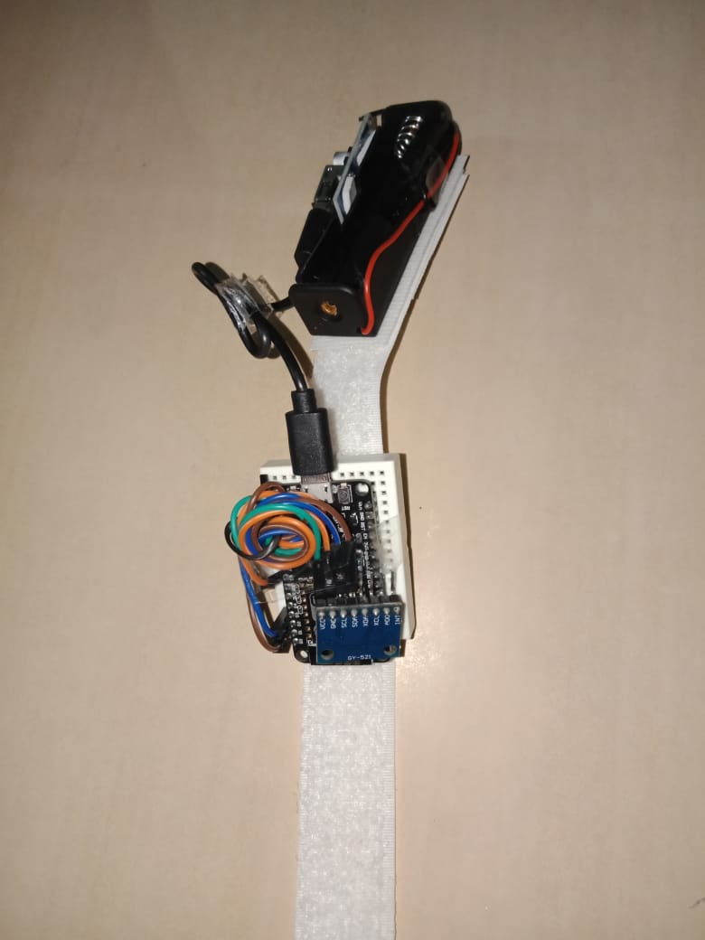

Fig 4.3.2 The design of the wristband (1)

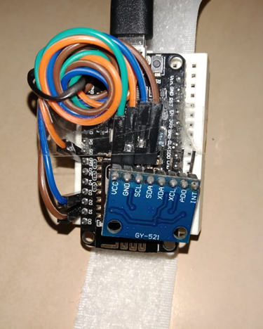

Fig 4.3.3 The design of the wristband (2)

* 1. **VOICE CONTROL THROUGH GOOGLE ASSISTANT**

**4.4.1 Google Assistant**

Google Assistant is a voice-activated assistant created by Google. Almost all Android devices have Google Assistant built in. The phrase "Hey Google"/"Ok Google" is used to communicate with the Google Assistant. Users may use Google Assistant to do a variety of things by speaking to it. It's a useful tool for automating applications.

**4.4.2 IFTTT**

“If This Then That (IFTTT) is a software solution that links various developers' apps, technologies, and services in order to activate one or more automated systems using those apps, equipment, and services”. “Applets, or basic conditional statements, are created using IFTTT”. These applets are sort of macros that they connect different apps to run automation in the background.

**4.4.3 Webhooks**

In web development, a webhook is a technique of using custom callbacks to enhance or change the behaviour of a web page or web service. A webhook delivers data in real time to other apps, so you can see it straight away.. Unlike traditional APIs, you won't have to poll for data very often to receive real-time results. It uses the HTTP post method to send data in JSON format. As a result, data is transferred to the cloud in response to the triggering event.

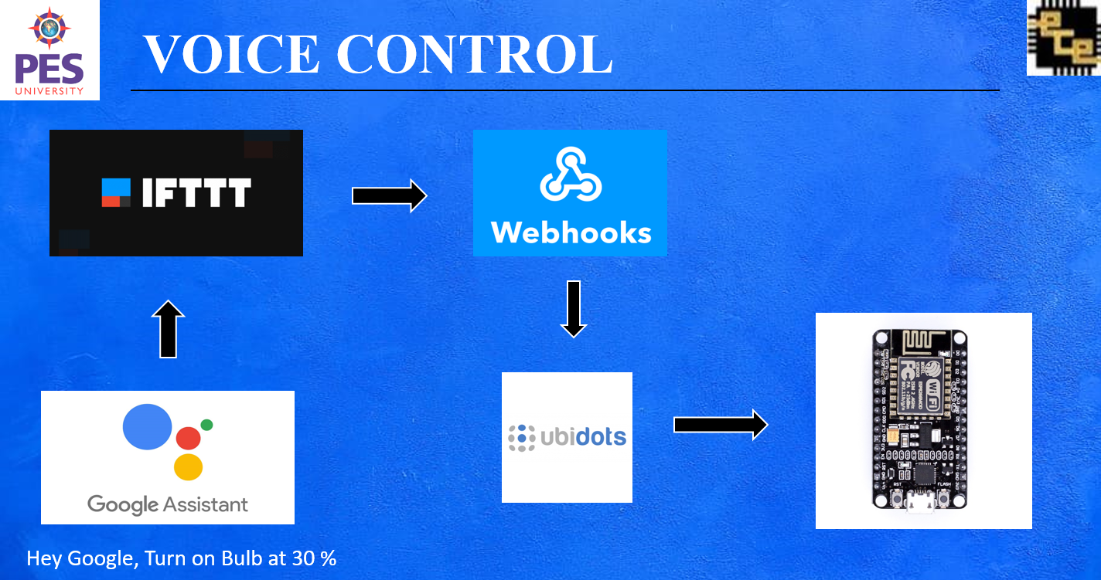

Fig 4.4.1 Block diagram of voice control

**4.3.4 Creating applets using IFTT**

1. Once you have downloaded the app, create an account by logging into your Gmail account.
2. Click on create to make a new applet.

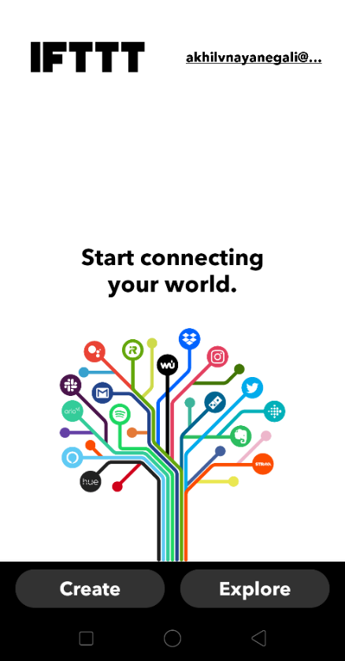

Fig 4.4.2 IFTTT home screen

1. Click on add in the If this block.

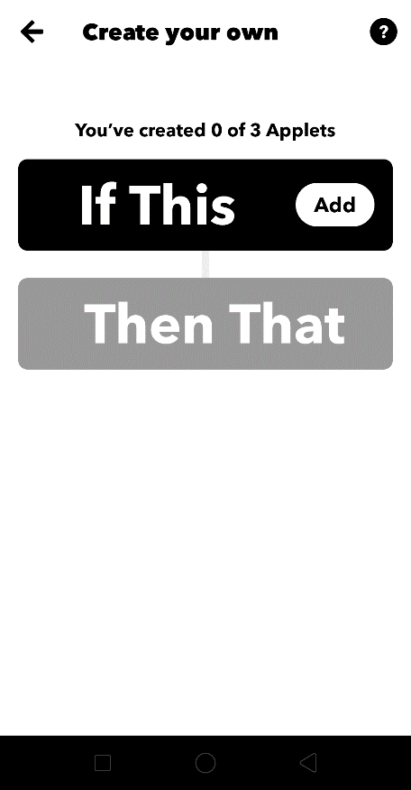

Fig 4.4.3 Creating new applet

1. Choose the google assistant services from the list.

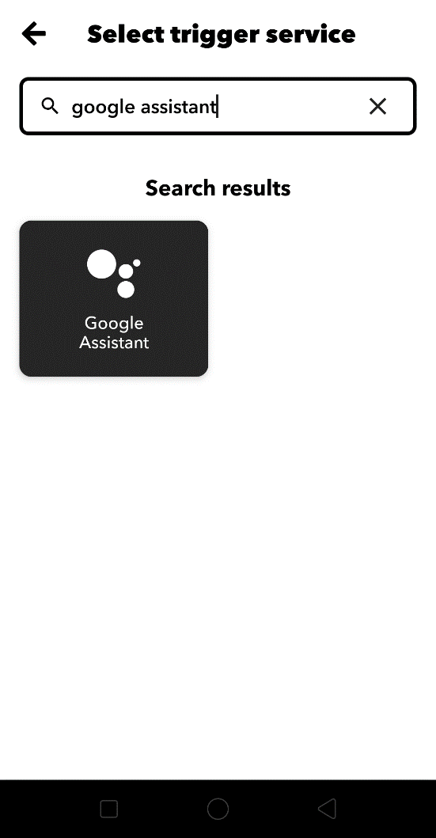

Fig 4.4.4 Selecting trigger device

1. In the next option, click on say a phrase with number option.

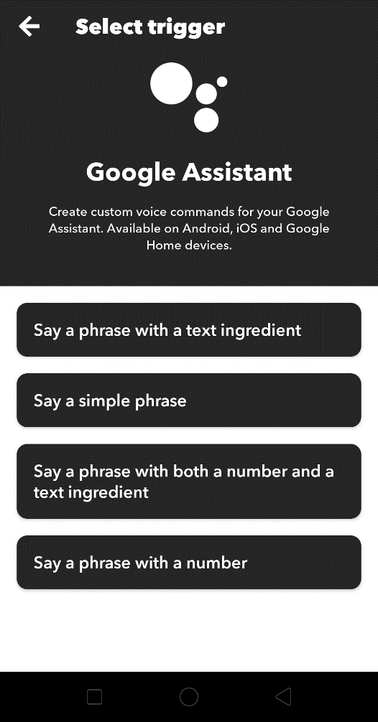

Fig 4.4.5 Selecting trigger options

1. Create simple commands like “Turn on the Bulb for # percent”

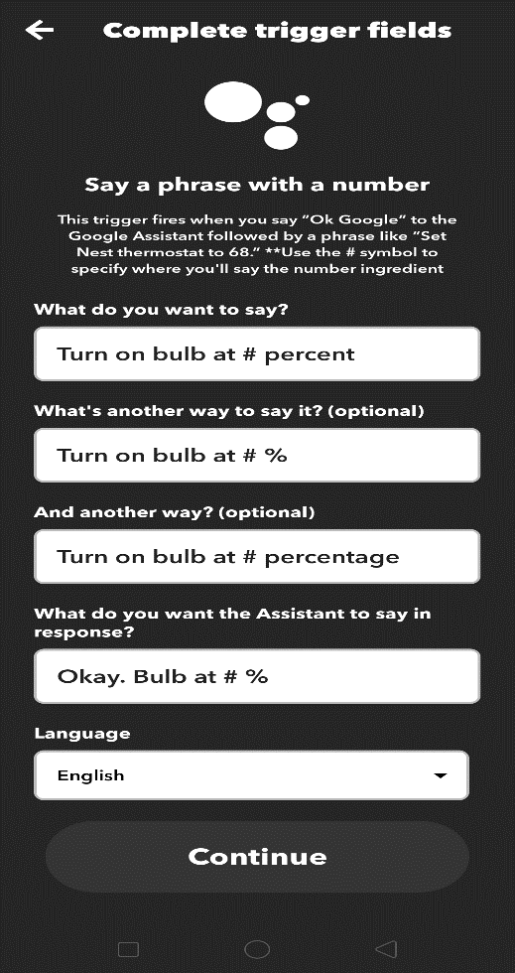

Fig 4.4.6 Filling the fields of the trigger device

1. Once the If this block is created, click on Then That block.
2. Choose webhooks from the list of services.

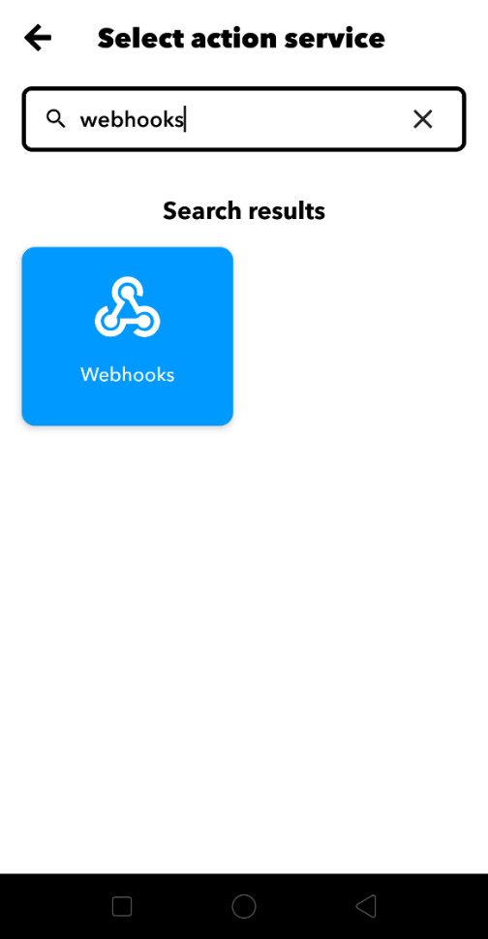

Fig 4.4.7 selection of the action service (1)

1. In the URL block, paste the Ubidots webhook link with the Device name that you have configured in the Ubidots dashboard and the Ubidots account token number.
2. Choose the GET option for the method option.
3. Choose application/JSON option for the content-type option.
4. In the Body block, type the variable name and the data type that you have configured in the Ubidots dashboard.

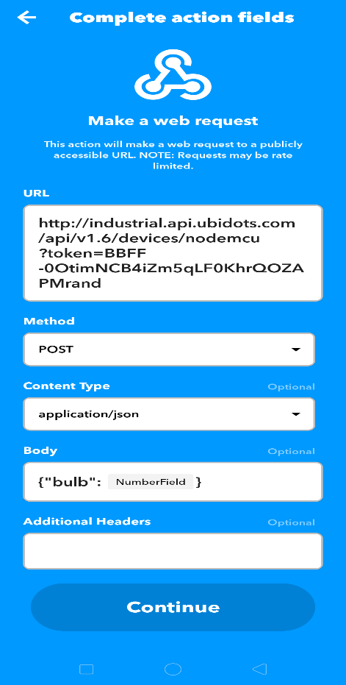

Fig 4.4.8 selection of the action service (2)

1. The applet has been created.

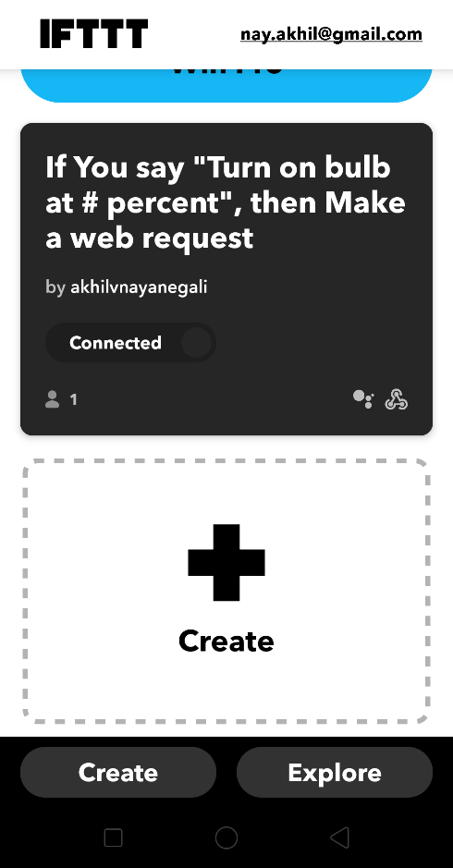

Fig 4.4.9 The IFTTT Dashboard

**4.3.5 Working of the voice-based control of the intensity of the appliances**.

Hey Google/ Ok Google is the hot keyword used to engage with the google assistant. The voice command is received by Google Assistant, which then converts it to data. Interpreted data is analyzed and checked whether the command is for IFTTT or some other application. If the data is intended for IFTTT, the data is analyzed and sent to IFTTT.. For example, If I say the phrase “turn on the bulb for 30%”. Google Assistant interprets the phrase as BULB =30% and the interpreted data is sent to the IFTTT. The IFTTT interprets this BULB= 30% as the trigger and the action field is activated to send the number field 30 to Ubidots MQTT server. The number received by then is displayed on the dashboard. The Subscriber circuit NodeMCU receives this value and the subscriber circuit operation is executed to adjust the intensity of the appliance as per the value received from the MQTT server.

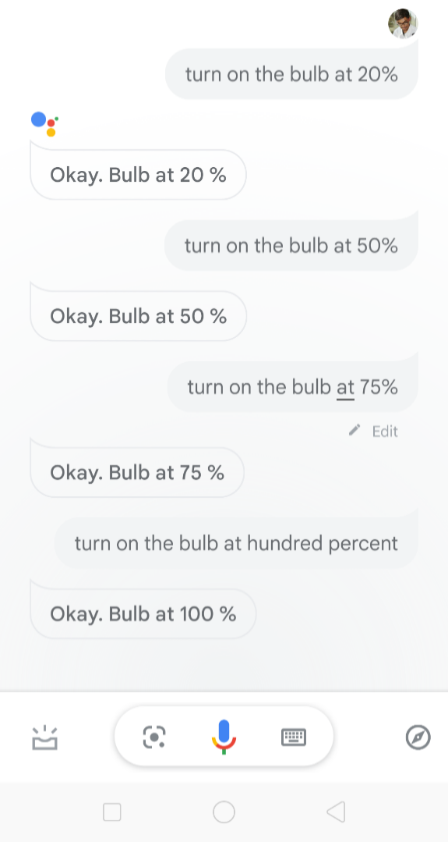

Fig 4.4.8 Voice Commands in Google Assistant

1. **RESULTS**

The suggested system entails data exchange between four entities. The main leading edge AC dimming circuit is the first. The wristband comes in second, followed by the Google Assistant and the Ubidots MQTT server. The MQTT protocol is used for communication. The subscriber is the leading edge AC dimming circuit. Publishers are the bracelet and Google Assistant. We may change the phase of AC input using Triac by using the Zero Crossing detector output as a reference. On the Ubidots Dashboard, we have implemented three controls: wristband, Google Assistant, and sidebar.

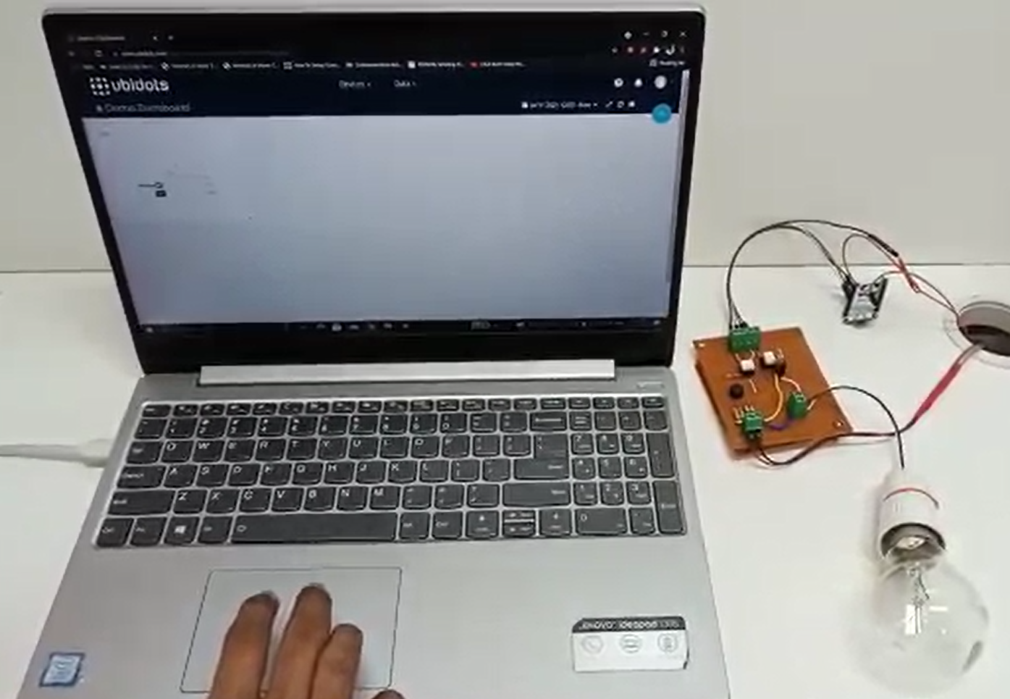

Fig 5.1 Slidebar Control of the appliance

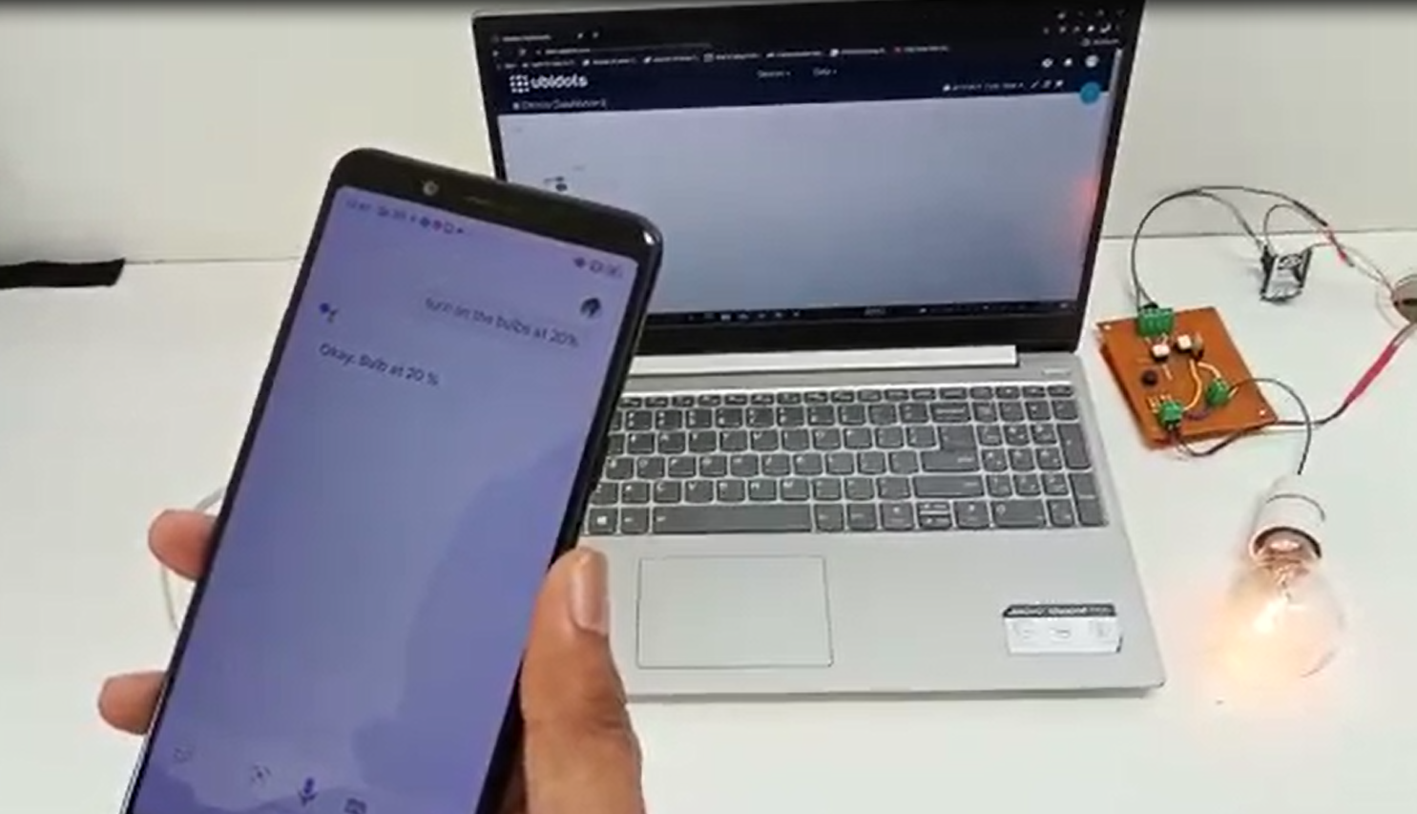

Fig 5.2 Voice control of the appliance

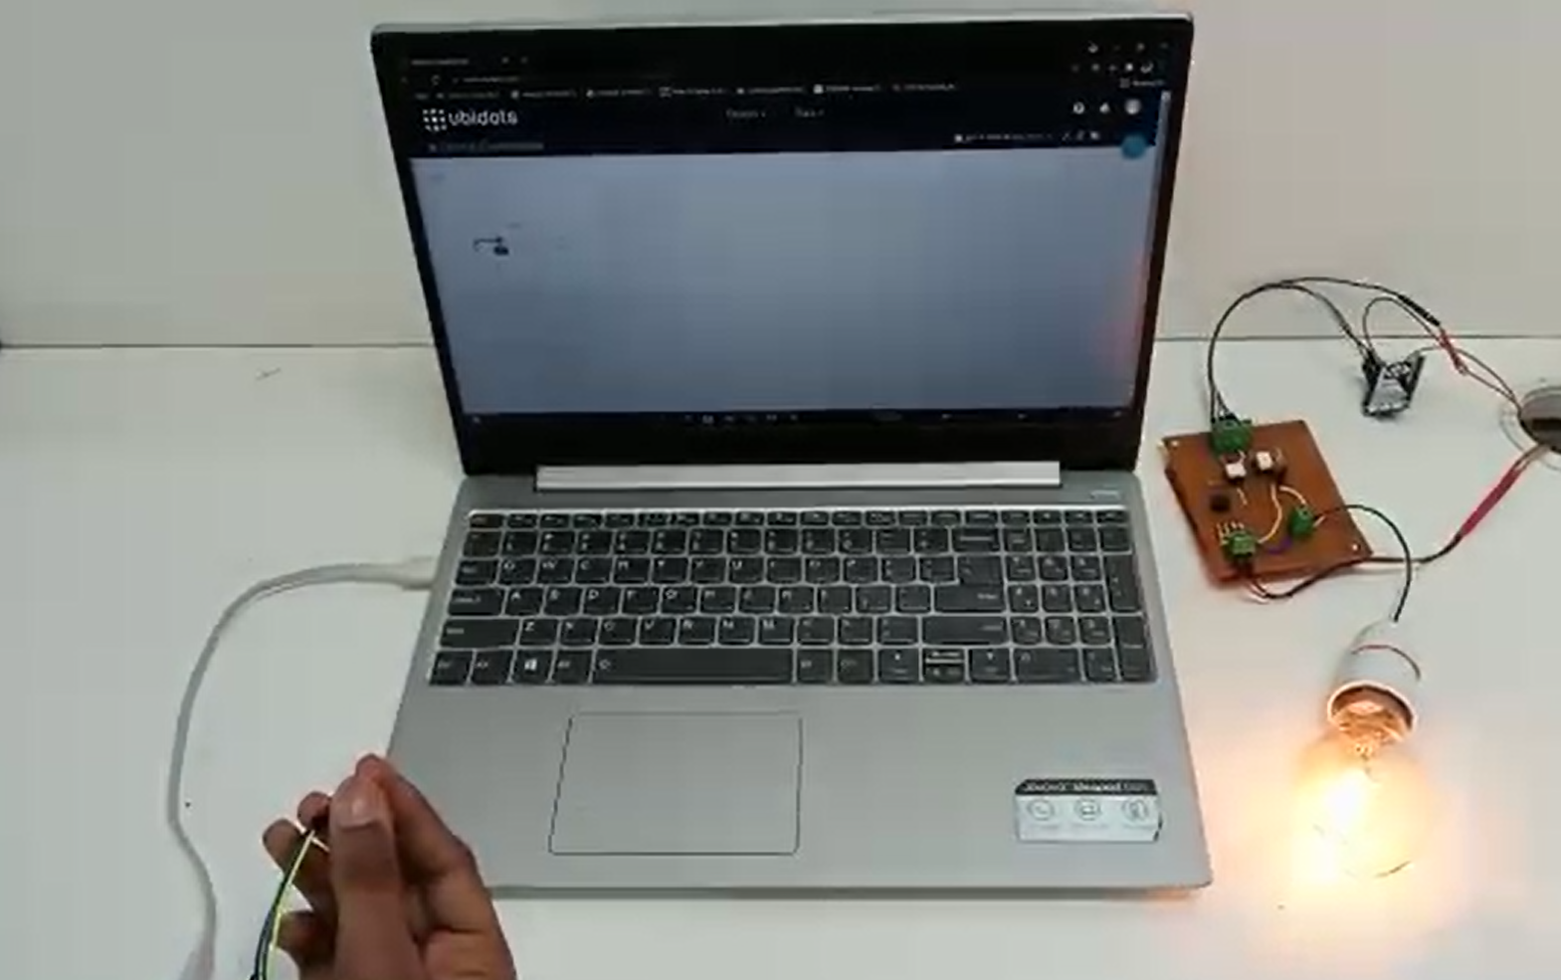

Fig 5.3 Gesture Control of the appliance

1. **CONCLUSION**

This report proposes a low-cost and innovative way to control home appliances with help of the MQTT Protocol as the communication protocol between the various components of the model. As a technical advancement, gesture-based interactivity has shown to have a potential of interaction between humans and electrical equipment or gadgets. The suggested gadget provides consumers with a novel experience that standard appliance control cannot provide, and our approach will improve the user-appliance interaction. Also, as the device be connected to the internet, we will be able to control our home appliances from anywhere in the world.

This system can be incorporated into a smartwatch which will have an inbuilt accelerometer and also the Google Assistant. The main advantage of the proposed method is scalability. Using this method, we can expand the control to a room or whole house, or the entire building. In the future, the study can concentrate on achieving seamless integration in smart homes and buildings. To support this proposed paradigm, a fail-safe method system can also be developed.

1. **REFERENCES**

[1] J. S. Kalsi and J. Singh Ubhi, "A study of Conventional Protocols applicable to the emerging IoT Systems and Devices," 2019 International Conference on Automation, Computational and Technology Management (ICACTM), 2019, pp. 395-399, doi: [10.1109/ICACTM.2019.8776826](https://doi.org/10.1109/ICACTM.2019.8776826)

[2] M. O. Al Enany, H. M. Harb and G. Attiya, "A Comparative analysis of MQTT and IoT application protocols," 2021 International Conference on Electronic Engineering (ICEEM), 2021, pp. 1-6, doi: [10.1109/ICEEM52022.2021.9480384](https://doi.org/10.1109/ICEEM52022.2021.9480384)

[3] Atmoko, Rachmad & Riantini, R & Hasin, M, “IoT real time data acquisition using MQTT protocol”, 2017 Journal of Physics: Conference Series. 853. 012003. 10.1088/1742-6596/853/1/012003.

[4] K. Loga Priya1, Mrs. S. Saranya2,” Voice-Activated Home Automation using NodeMCU”, International Research Journal of Engineering and Technology (IRJET), Volume: 07 Issue: 02 | Feb 2020

[5] N. Nikolov, "Research of MQTT, CoAP, HTTP and XMPP IoT Communication protocols for Embedded Systems," 2020 XXIX International Scientific Conference Electronics (ET), 2020, pp. 1-4, doi: [10.1109/ET50336.2020.9238208](https://doi.org/10.1109/ET50336.2020.9238208)

[6] Assad Mohammed , Amar Seeam, Xavier Bellekens z, Kamila Nieradzinska x, Visham Ramsurrun , “Gesture based IoT Light Control for Smart Clothing” , 2016 IEEE International Conference on Emerging Technologies and Innovative Business Practices for the Transformation of Societies (EmergiTech), Avaliable online:[10.1109/EmergiTech.2016.7737326](https://www.researchgate.net/deref/http:/dx.doi.org/10.1109/EmergiTech.2016.7737326)

[7] Sajid Nagarboudi Patel a, R.D.Salagarb ,”A Review on Iot Light Control for Smart Clothing using Gesture Control” International Journal of Innovative and Emerging Research in Engineering Volume 4, Issue 6, 2017.

[8] Yash Govilkar, Dr. Rupesh Jaiswal , “A Gesture Based Home Automation System” , International Journal for Research in Applied Science & Engineering Technology (IJRASET), *Volume 7 Issue XI, Nov 2019,* Available online: <http://doi.org/10.22214/ijraset.2019.11081>

[9] Osheen Bindroo, Komal Saxena, Sunil Kumar Khatri “A Wearable NFC Wristband for Remote Home Automation System”,  2017 2nd International Conference on Telecommunication and Networks (TEL-NET), Available Online :[10.1109/TEL-NET.2017.8343563](https://doi.org/10.1109/TEL-NET.2017.8343563)

[10] Ravi Kishore Kodali, Borra Yatish Krishna Yogi, Gudibanda Nagesh Sharan Sai and Jehova Honey Domma,” Implementation of Home Automation Using CoAP” , Proceedings of TENCON 2018 - 2018 IEEE Region 10 Conference (Jeju, Korea, 28-31 October 2018)

[11] Kamelya Dehghani Kohnehshahri, Mohammad Hasan Kargar, Fatemeh Soleimani-Roozbahani,” The Effect of Using COAP Protocol on Reducing Energy Consumption in Smart Houses”, Int. J. Advanced Networking and Applications, Volume: 10, Issue: 03Pages: 3843-3852 (2018) ISSN: 0975-0290

[12] Mubashir Ali1, Zarsha Nazim, Waqar Azeem , Khadija Javed , Maria Tariq, Muhammad Haroon, Aamir Hussain, ‘An IoT based Approach for Efficient Home Automation with ThingSpeak’, International Journal of Advanced Computer Science and Applications, Vol. 11, No. 6, 2020

[13] Mr.Rohit Kadam ,Mr.Pranav Mahamuni ,Mr.Yash Parikh, ‘Smart Home System’, International Journal of Innovative Research in Advanced Engineering (IJIRAE) ISSN: 2349-2163 Volume 2 Issue 1, January 2015

[14] Shruthi.J1 , Ramya.S2 , Bharathi.R, ‘HOME APPLIANCE CONTROL FOR USERS WITH MOTOR DISABILITIES USING SMART PHONE’, International Journal of Innovative Research in Advanced Engineering (IJIRAE) ISSN: 2349-2163 Volume 1 Issue 6, July 2014

[15] Praful Nandankar, Akash Zade, Namrata Wadhai, ‘HOME AUTOMATION SYSTEM USING ANDROID MOBILE PHONE’, International Journal of Innovative Research in Advanced Engineering (IJIRAE) ISSN: 2349-2163 Issue 04, Volume 5, April 2018

[16] Sarika N. Gaikwad, Prof. M. S. Chaudhari, ‘Home Automation System Embedded In an Internet-Of-Things Platform’, International Journal of Advanced Research in Electrical, Electronics and Instrumentation Engineering, Vol. 7, Issue 7, July 2018, Website: [www.ijareeie.com](http://www.ijareeie.com)

[17] Shikhar Sharma1, Shripad S. Desai, ’ Home Automation System (HAS) using Android for Mobile Phone’, International Journal Of Innovative Research In Technology ISSN: 2349-6002, Volume 7 Issue 8 , January 2021

[18] Ms. Pooja Bhagat-Thakre, Vrushali Deshpande, Aishwarya Daundkar, Sanika Haval, Rohankumar Patel, ‘Accelerometer based data glove for blind and dumb’, International Journal of Creative Research Thoughts (IJCRT), ISSN: 2320-2882

[19] Jun Xu, Xiong Zhang and Meng Zhou, ‘A High-Security and Smart Interaction System Based on Hand Gesture Recognition for Internet of Things’, Hindawi Security and Communication Networks Volume 2018, Article ID 4879496, 11 pages, 6 June 2018, Website-https://doi.org/10.1155/2018/4879496

[20] Indu Dokare, Raghav Potdar, Rahul Sohandani, Soham Phutane, Alish Wadhwani, ‘Voice Controlled Smart Home’, International Journal of Future Generation Communication and Networking, Vol. 13, No. 1s, (2020), pp. 368—376, ISSN: 2233-7857 IJFGCN

[21] E.Saraswathi, Ajay Kumar, Jaspal Singh, Janak Mohanty, Yatharth Mishra, ‘Arduino Based Home Automation System Using MQTT Protocol Incorporating Internet of Things’, Journal of Network Communications and Emerging Technologies (JNCET), Volume 8, Issue 5, May 2018

1. **Annexure – 1**

**CODE**

The Arduino IDE controls the circuit board until it is either turned off or reset. It is made up of two functions: setup () and loop (). The Arduino Integrated Development Environment (IDE) is a piece of software that allows you to build programmes and communicate with your microcontroller. The C and C++ programming languages are supported in a reduced form.

**The subscriber Circuit Code**

/****************************************

* Include Libraries

****************************************/

#include "UbidotsESPMQTT.h"

/****************************************

* Define Constants

****************************************/

#define TOKEN "BBFF-0OtimNCB4iZm5qLF0KhrQOZAPMrand" //Your Ubidots TOKEN

#define WIFINAME "JioFiber 2.4G" //Your SSID

#define WIFIPASS "12345678" //Your Wifi Pass

#define triacPulse 4 //D2

#define ZVC 12 //D6

**Ubidots** client(TOKEN);

/****************************************

* Auxiliar Functions

****************************************/

int val;

void ICACHE_RAM_ATTR acon()

{

 delayMicroseconds(val); // read AD0

 digitalWrite(triacPulse, HIGH);

 /

 delayMicroseconds(50);//delay 50 uSec on output pulse to turn on triac

 digitalWrite(triacPulse, LOW);

 // Serial.println(digitalRead(triacPulse));

}

void callback(char* topic, byte* payload, unsigned int length) {

**Serial**.print("Message arrived [");

**Serial**.print(topic);

**Serial**.print("] ");

 int j= length-1;

 for (int i=0;i<length;i++) {

**Serial**.print((char)payload[i]);

   int mymsg = atoi ((const char*)payload);

   val=mymsg;

 }

 //Serial.print(val);

 val=map(val,0,100,7200,200);

**Serial**.println();

}

/****************************************

* Main Functions

****************************************/

void setup() {

 // put your setup code here, to run once:

**Serial**.begin(115200);

 client.setDebug(true);// Pass a true or false bool value to activate debug messages

 client.wifiConnection(WIFINAME, WIFIPASS);

 client.begin(callback);

 client.ubidotsSubscribe("nodemcu","bulb");//Insert the dataSource and Variable's Labels

  pinMode(ZVC, INPUT_PULLUP);// pull up

  pinMode(triacPulse, OUTPUT);

 attachInterrupt(ZVC, acon, FALLING); //attach Interrupt at PIN2

 }

void loop() {

 // put your main code here, to run repeatedly:

 if(!client.connected()){

     client.reconnect();

     client.ubidotsSubscribe("nodemcu","bulb"); //Insert the dataSource and Variable's Labels

     }

 client.loop();

 }

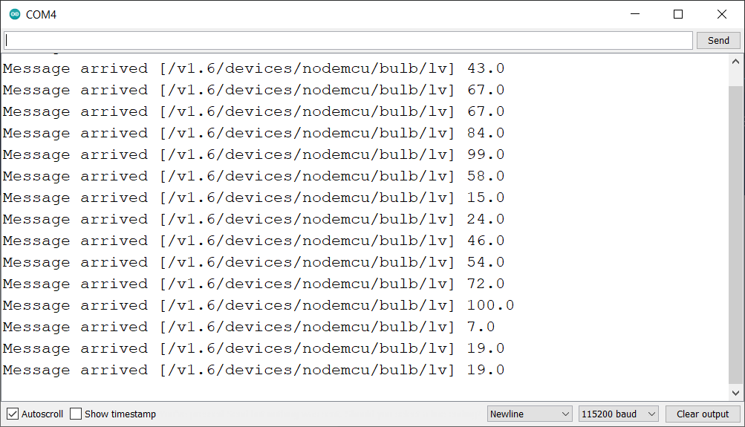

Fig 4.5.1 Output of the subscriber circuit

**The Publisher Code**

#include "UbidotsESPMQTT.h"

#include <Adafruit_MPU6050.h>

#include <Adafruit_Sensor.h>

#include <Wire.h>

Adafruit_MPU6050 mpu;

int ax, ay, az;

/****************************************

  Define Constants

****************************************/

#define TOKEN "BBFF-0OtimNCB4iZm5qLF0KhrQOZAPMrand"// Your Ubidots TOKEN

#define WIFINAME "JioFiber 2.4G" //Your SSID

#define WIFIPASS "12345678" // Your Wifi Pass

**Ubidots** client(TOKEN);

/****************************************

  Auxiliar Functions

****************************************/

void callback(char* topic, byte* payload, unsigned int length) {

**Serial**.print("Message arrived [");

**Serial**.print(topic);

**Serial**.print("] ");

 for (int i = 0; i < length; i++) {

**Serial**.print((char)payload[i]);

 }

**Serial**.println();

}

/****************************************

  Main Functions

****************************************/

void setup() {

 // Pass a true or false bool value to activate debug messages

 client.setDebug(true);

**Serial**.begin(115200);

 client.wifiConnection(WIFINAME, WIFIPASS);

 client.begin(callback);

**Serial**.println("Adafruit MPU6050 test!");

 if (!mpu.begin()) {

**Serial**.println("Failed to find MPU6050 chip");

   while (1) {

     delay(10);

   }

 }

**Serial**.println("MPU6050 Found!");

 mpu.setAccelerometerRange(MPU6050_RANGE_8_G);

**Serial**.print("Accelerometer range set to: ");

 switch (mpu.getAccelerometerRange()) {

   case MPU6050_RANGE_2_G:

**Serial**.println("+-2G");

     break;

   case MPU6050_RANGE_4_G:

**Serial**.println("+-4G");

     break;

   case MPU6050_RANGE_8_G:

**Serial**.println("+-8G");

     break;

   case MPU6050_RANGE_16_G:

**Serial**.println("+-16G");

     break;

 }

 mpu.setGyroRange(MPU6050_RANGE_500_DEG);

**Serial**.print("Gyro range set to: ");

 switch (mpu.getGyroRange()) {

   case MPU6050_RANGE_250_DEG:

**Serial**.println("+- 250 deg/s");

     break;

   case MPU6050_RANGE_500_DEG:

**Serial**.println("+- 500 deg/s");

     break;

   case MPU6050_RANGE_1000_DEG:

**Serial**.println("+- 1000 deg/s");

     break;

   case MPU6050_RANGE_2000_DEG:

**Serial**.println("+- 2000 deg/s");

     break;

 }

 mpu.setFilterBandwidth(MPU6050_BAND_21_HZ);

**Serial**.print("Filter bandwidth set to: ");

 switch (mpu.getFilterBandwidth()) {

   case MPU6050_BAND_260_HZ:

**Serial**.println("260 Hz");

     break;

   case MPU6050_BAND_184_HZ:

**Serial**.println("184 Hz");

     break;

   case MPU6050_BAND_94_HZ:

**Serial**.println("94 Hz");

     break;

   case MPU6050_BAND_44_HZ:

**Serial**.println("44 Hz");

     break;

   case MPU6050_BAND_21_HZ:

**Serial**.println("21 Hz");

     break;

   case MPU6050_BAND_10_HZ:

**Serial**.println("10 Hz");

     break;

   case MPU6050_BAND_5_HZ:

**Serial**.println("5 Hz");

     break;

 }

**Serial**.println("");

 delay(100);

}

void loop() {

 // put your main code here, to run repeatedly:

 if (!client.connected()) {

   client.reconnect();

 }

 sensors_event_t a, g, temp;

 mpu.getEvent(&a, &g, &temp);

 ax = map(a.acceleration.x, -10, 10, 0, 100);

 ay = map(a.acceleration.y, -9, 9, 0, 100);

 if (ax > 30 && ax < 70)

 {

   client.add("bulb", ay);

   client.ubidotsPublish("nodemcu");

 }

 client.loop();

}

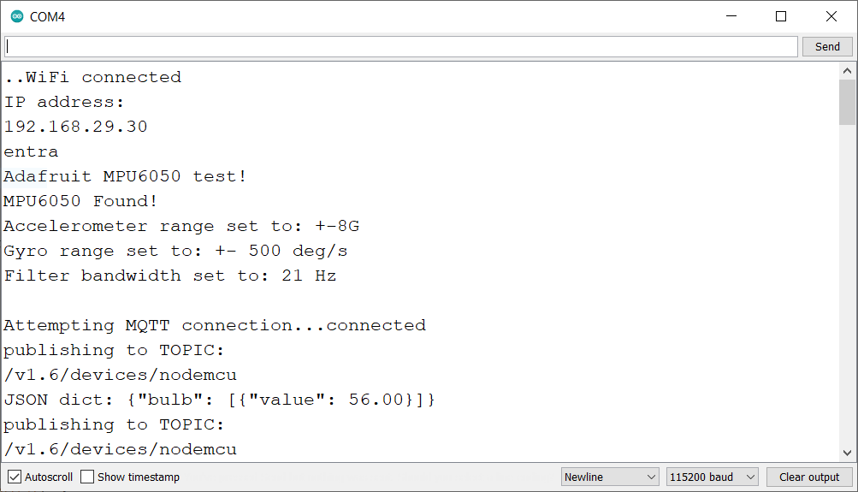Fig 4.5.2 Output of the Publisher circuit on serial monitor (1)

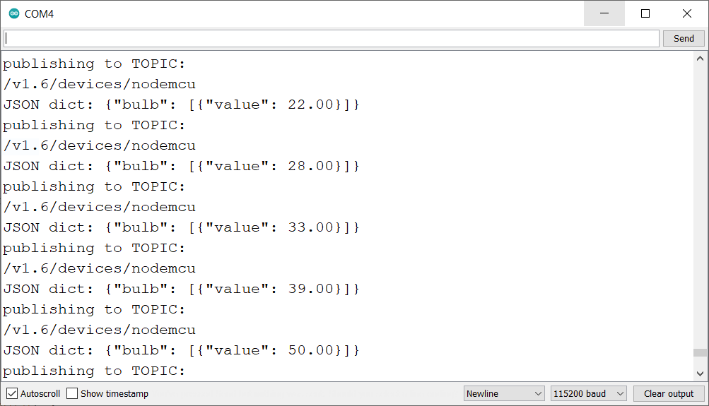

Fig 4.5.2 Output of the Publisher circuit on serial monitor (2)

II. PLAGIARISM REPORT

